**DATABASE MANAGEMENT SYSTEM**

**LABORATORY**

**RETAIL BILLING MANAGEMENT SYSTEM**

##### A REPORT

###### ***Submitted by***

##### 

##### VIJESH PETHURAM K (9517202106056)

**PRABHU R (9517202106032)**

MEPCO SCHLENK ENGINEERING COLLEGE, SIVAKASI

DECEMBER 2022

**BONAFIDE CERTIFICATE**

Certified that this project report is the bonafide work of **K. VIJESH PETHURAM (21BIT058) (9517202106056), R. PRABHU** (**9517202106032) (21BIT042)** who carried out the project work under my supervision.

**SIGNATURE** **SIGNATURE**

**Dr. T. Revathi, M.E.,Ph.D., Mrs.R.Venitta Raj, M.E., (PhD),**

**HEAD OF THE DEPARTMENT STAFF IN-CHARGE**

**Senior Professor Assistant Professor**

**Information Technology Information Technology**

**Mepco Schlenk Engineering College Mepco Schlenk Engineering College**

**Virudhunagar Dt. – 626 005 Virudhunagar Dt. – 626 005**

REVISION HISTORY

|  |  |  |  |
| --- | --- | --- | --- |
| Date | Version | Description | Author |
|  |  |  |  |
|  |  |  |  |
|  |  |  |  |

INDEX

1. Introduction………………………………….…………….…..5

1. 1. Purpose………………………………………..................5

1. 2. Scope, Approach, Methods……………………...............5

1. 3. Points of Contact…………………………..……..……...6

2. System Overview……………………………………………...6

3. ER-diagram………………...……………….............................7

4. Schema Diagram……………………….…..……………….…8

5. Quality Assurance Process…………...……..............................7

6. Database Design and Functionalities...……..............................9

6. 1. Design & Functional Support………................................9

6. 2. Requirements………………………………………….....9

6. 3. Procedures……………………………………………….9

6. 4. Triggers………………………………………………….10

7. User Management………………………...…………………..10

8. Non-Functional Design……………………..………………...10

8. 1. Security Design………………………………………....10

8. 2. Availability……………………………..........................11

8. 3. Performance………………………....………………….11

9. Code………………………………………..…………………12

10. Output……………………………………….........................78

1. Introduction

The database management for Billing details will be very useful for the Office staffs to create Bills instantly. Also, they can add customers, delete customers, add products, etc. easily.

1. 1. Purpose

Our Software will be very useful for all Businesses. Proprietors can see the billing information and employees can also access them. This will very useful for Management and to promote sales.

1. 2. Scope, Approach and Methods

Our software can be used in Shops, Stores and can even be used in Industries to know the Sales report of the day and they can see the previous reports too. Here, we can generate a bill, add customer details, product details, etc. For instance, if we want to see the customers who bought a specific product, we can sort in the Display bill page.

1. 3. Points of Contact

|  |  |  |
| --- | --- | --- |
| Role | Name | E-mail |
| Project Manager | Mrs. R. Venitta Raj | venittaraj@mepcoeng.ac.in |
| Team Members | Vijesh Pethuram K  Prabhu R | vijesh.moses_bit25@mepcoeng.ac.in  rprabhubarath_bit25@mepcoeng.ac.in |

2. System Overview

In our Billing management system, we can add customers, remove customers, add products, remove products, generate Bills, display bills, search customers, products or bills.

We have used Java to develop the frames and we used MySQL to handle the Database in backend. We have used InnoDB Data Storage Engine for this project which is used in MySQL.

|  |  |  |  |
| --- | --- | --- | --- |
| Vendor | Product | Version | Comments |
| Oracle | MySQL server | 8.01 | Database Management System |

3. ER-diagram

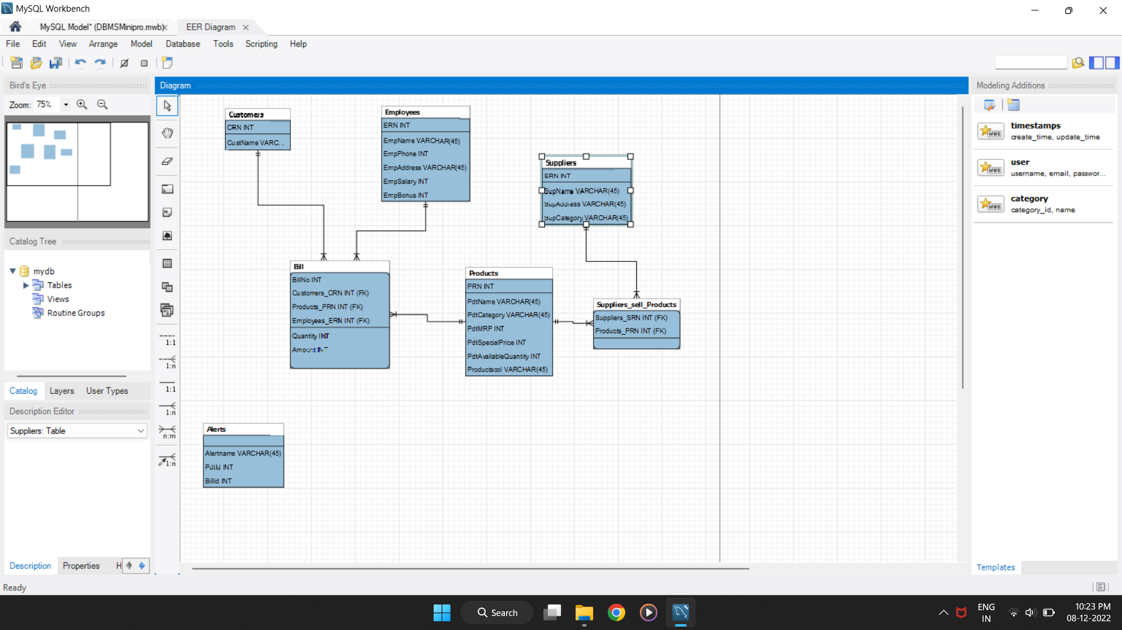

4. Schema Diagram

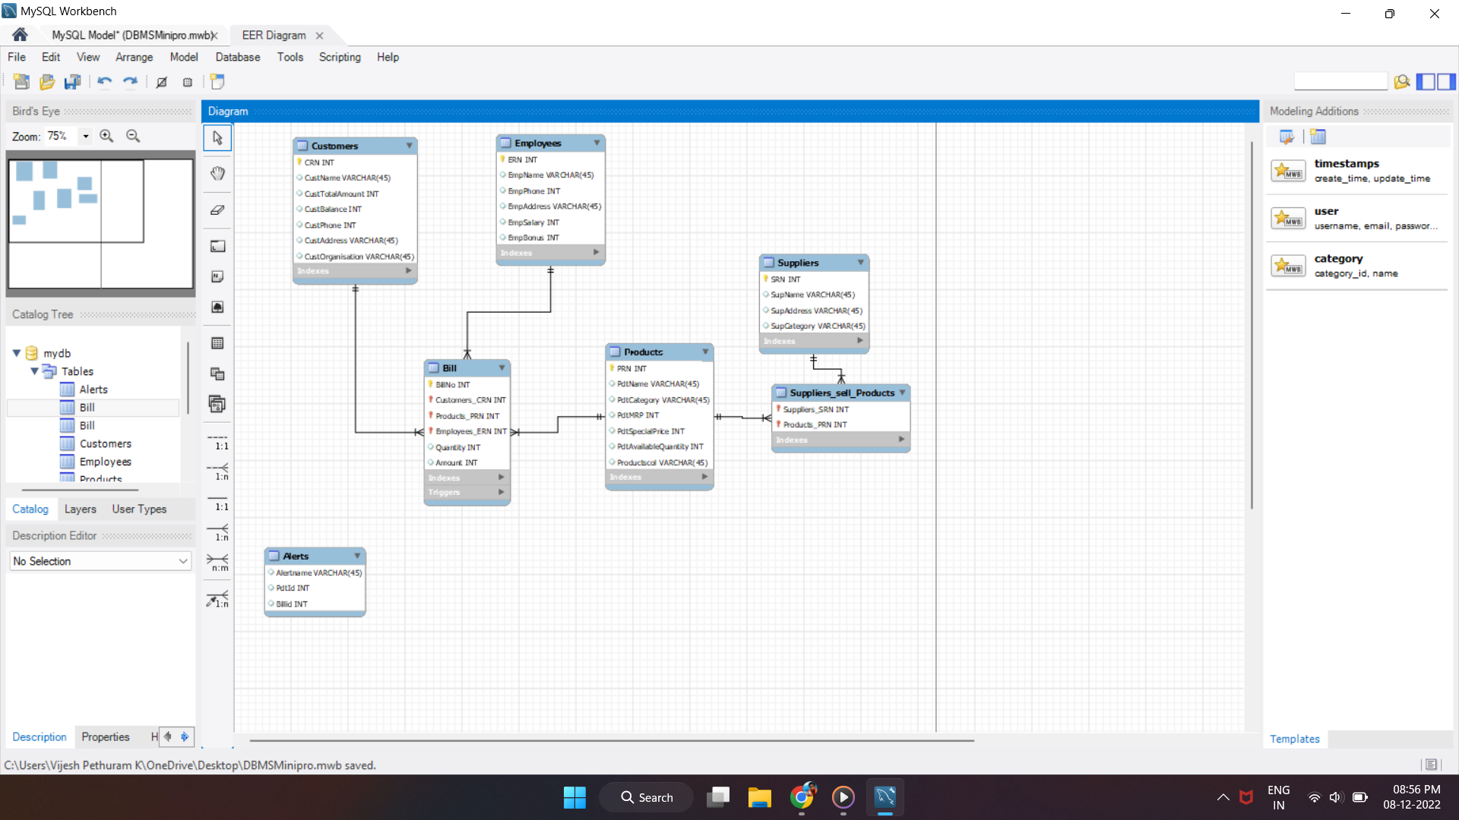

5. Quality Assurance

We assure you that our software will do the best for Billing as per your needs in an easy manner. We believe that there will be no error since our team has tested it thoroughly.

6. Database Design and Functionalities

6. 1. Design & Functional Support

Our database was developed using MySQL 8.01 command line to store the values of the Billing details i.e., The details that have been provided to the form by the user will be stored in the Database. We have used Java language to create Forms and we have used the same to connect each form. For editing and compiling, we have used Apache NetBeans IDE 14.

By using the JDBC Driver we connected the database and the forms i.e., what the user entered in the form that will be automatically stored in the database.

By using this we can easily insert, delete, update, etc, and this will be very user-friendly.

6. 2. Requirements

* MySQL 8.01 Command Line Client
* Apache NetBeans IDE 14
* JDBC Driver

6. 3. Procedures

Procedures are used to run a stored code when it is called by query. We have used the procedure ShowCRN in our Project.

It is used to display the Customers based on CRN. It is then called in the Java program.

6. 4. Triggers

Triggers are used to run a stored code when an event occurs. We have used the Trigger Billing for Billing on our Project.

It is used to update the Customers table and products table after there is an insertion on billing.

6. 4. 1. Billing trigger:

*Create trigger Billing*

*After insert on bills*

*Customers set CustTotalAmount=CustTotalAmount+new.Amount where CRN=new.CRN;*

*insert into billbase values(new.Billno,new.CRN,new.PRN,new.Quantity,new.Amount,NULL,NULL);*

*update billbase set cname=(select CustName from customers where CRN=new.CRN) where Billno=new.Billno;*

*update billbase set pname=(select PdtName from products where PRN=new.PRN) where Billno=new.Billno;*

*end;*

7. User Management

Our Billing management system will be very useful to do analysis. Also, we can do Search operation and Sort operations. This process is more user-friendly.

8. Non-Functional Design

8. 1. Security Design

Our database will be more secure because we set it up with passwords. Employees will have a unique username and password. After the credentials are verified, they will be redirected to access details.

8. 2. Availability

Our database will be available at all times and Employees can access it using the credentials provided to them seamlessly.

8. 3. Performance

The performance of our database system is good and we are working on it to improve it. Even though, the InnoDB Engine is faster, we are importing various Engines to increase the speed and performance.

9. Code:

/*

* Click nbfs://nbhost/SystemFileSystem/Templates/Licenses/license-default.txt to change this license

* Click nbfs://nbhost/SystemFileSystem/Templates/GUIForms/JFrame.java to edit this template

*/

import javax.swing.JOptionPane;

/**

*

* @author Vijesh Pethuram K

*/

public class Login extends javax.swing.JFrame {

/**

* Creates new form Login

*/

public Login() {

initComponents();

}

/**

* This method is called from within the constructor to initialize the form.

* WARNING: Do NOT modify this code. The content of this method is always

* regenerated by the Form Editor.

*/

@SuppressWarnings("unchecked")

// <editor-fold defaultstate="collapsed" desc="Generated Code">

private void initComponents() {

jLabel1 = new javax.swing.JLabel();

jLabel2 = new javax.swing.JLabel();

jLabel3 = new javax.swing.JLabel();

jTextField1 = new javax.swing.JTextField();

jPasswordField1 = new javax.swing.JPasswordField();

jButton1 = new javax.swing.JButton();

jButton2 = new javax.swing.JButton();

jCheckBox1 = new javax.swing.JCheckBox();

jLabel4 = new javax.swing.JLabel();

setDefaultCloseOperation(javax.swing.WindowConstants.EXIT_ON_CLOSE);

setLocation(new java.awt.Point(420, 160));

getContentPane().setLayout(new org.netbeans.lib.awtextra.AbsoluteLayout());

jLabel1.setFont(new java.awt.Font("Segoe UI", 1, 12)); // NOI18N

jLabel1.setForeground(new java.awt.Color(255, 255, 255));

jLabel1.setText("Selvam Marketing Login");

getContentPane().add(jLabel1, new org.netbeans.lib.awtextra.AbsoluteConstraints(238, 26, 140, -1));

jLabel2.setFont(new java.awt.Font("Segoe UI", 1, 12)); // NOI18N

jLabel2.setForeground(new java.awt.Color(255, 255, 255));

jLabel2.setText("Password:");

getContentPane().add(jLabel2, new org.netbeans.lib.awtextra.AbsoluteConstraints(161, 179, 74, 25));

jLabel3.setFont(new java.awt.Font("Segoe UI", 1, 12)); // NOI18N

jLabel3.setForeground(new java.awt.Color(255, 255, 255));

jLabel3.setText("UID:");

getContentPane().add(jLabel3, new org.netbeans.lib.awtextra.AbsoluteConstraints(190, 120, 74, 25));

getContentPane().add(jTextField1, new org.netbeans.lib.awtextra.AbsoluteConstraints(296, 119, 107, -1));

jPasswordField1.addActionListener(new java.awt.event.ActionListener() {

public void actionPerformed(java.awt.event.ActionEvent evt) {

jPasswordField1ActionPerformed(evt);

}

});

getContentPane().add(jPasswordField1, new org.netbeans.lib.awtextra.AbsoluteConstraints(296, 182, 107, -1));

jButton1.setText("Submit");

jButton1.addActionListener(new java.awt.event.ActionListener() {

public void actionPerformed(java.awt.event.ActionEvent evt) {

jButton1ActionPerformed(evt);

}

});

getContentPane().add(jButton1, new org.netbeans.lib.awtextra.AbsoluteConstraints(340, 290, -1, -1));

jButton2.setText("Exit");

jButton2.addActionListener(new java.awt.event.ActionListener() {

public void actionPerformed(java.awt.event.ActionEvent evt) {

jButton2ActionPerformed(evt);

}

});

getContentPane().add(jButton2, new org.netbeans.lib.awtextra.AbsoluteConstraints(170, 290, -1, -1));

jCheckBox1.setForeground(new java.awt.Color(255, 255, 255));

jCheckBox1.setText("Show Password");

jCheckBox1.addActionListener(new java.awt.event.ActionListener() {

public void actionPerformed(java.awt.event.ActionEvent evt) {

jCheckBox1ActionPerformed(evt);

}

});

getContentPane().add(jCheckBox1, new org.netbeans.lib.awtextra.AbsoluteConstraints(420, 185, -1, -1));

jLabel4.setIcon(new javax.swing.ImageIcon(getClass().getResource("/Pink-Gradient-Wallpaper.jpg"))); // NOI18N

jLabel4.setText("jLabel4");

getContentPane().add(jLabel4, new org.netbeans.lib.awtextra.AbsoluteConstraints(0, 0, 630, 515));

pack();

}// </editor-fold>

private void jPasswordField1ActionPerformed(java.awt.event.ActionEvent evt) {

// TODO add your handling code here:

}

private void jButton2ActionPerformed(java.awt.event.ActionEvent evt) {

// TODO add your handling code here:

int a=JOptionPane.showConfirmDialog(null,"Do you want to exit?","Select",JOptionPane.YES_NO_OPTION);

if(a==0)

{

System.exit(0);

}

}

private void jButton1ActionPerformed(java.awt.event.ActionEvent evt) {

// TODO add your handling code here:

if(jTextField1.getText().equals("Admin") && jPasswordField1.getText().equals("1234"))

{

setVisible(false);

new Admin().setVisible(true);

}

else if(jTextField1.getText().equals("Employee") && jPasswordField1.getText().equals("1234"))

{

setVisible(false);

new Emp().setVisible(true);

}

else

JOptionPane.showMessageDialog(null, "Incorrect Credentials!");

}

private void jCheckBox1ActionPerformed(java.awt.event.ActionEvent evt) {

// TODO add your handling code here:

if(jCheckBox1.isSelected())

{

jPasswordField1.setEchoChar((char)0);

}

else

jPasswordField1.setEchoChar('*');

}

/**

* @param args the command line arguments

*/

public static void main(String args[]) {

/* Set the Nimbus look and feel */

//<editor-fold defaultstate="collapsed" desc=" Look and feel setting code (optional) ">

/* If Nimbus (introduced in Java SE 6) is not available, stay with the default look and feel.

* For details see http://download.oracle.com/javase/tutorial/uiswing/lookandfeel/plaf.html

*/

try {

for (javax.swing.UIManager.LookAndFeelInfo info : javax.swing.UIManager.getInstalledLookAndFeels()) {

if ("Nimbus".equals(info.getName())) {

javax.swing.UIManager.setLookAndFeel(info.getClassName());

break;

}

}

} catch (ClassNotFoundException ex) {

java.util.logging.Logger.getLogger(Login.class.getName()).log(java.util.logging.Level.SEVERE, null, ex);

} catch (InstantiationException ex) {

java.util.logging.Logger.getLogger(Login.class.getName()).log(java.util.logging.Level.SEVERE, null, ex);

} catch (IllegalAccessException ex) {

java.util.logging.Logger.getLogger(Login.class.getName()).log(java.util.logging.Level.SEVERE, null, ex);

} catch (javax.swing.UnsupportedLookAndFeelException ex) {

java.util.logging.Logger.getLogger(Login.class.getName()).log(java.util.logging.Level.SEVERE, null, ex);

}

//</editor-fold>

/* Create and display the form */

java.awt.EventQueue.invokeLater(new Runnable() {

public void run() {

new Login().setVisible(true);

}

});

}

}

import javax.swing.JOptionPane;

/*

* Click nbfs://nbhost/SystemFileSystem/Templates/Licenses/license-default.txt to change this license

* Click nbfs://nbhost/SystemFileSystem/Templates/GUIForms/JFrame.java to edit this template

*/

/**

*

* @author Vijesh Pethuram K

*/

public class Admin extends javax.swing.JFrame {

/**

* Creates new form Admin

*/

public Admin() {

initComponents();

}

/**

* This method is called from within the constructor to initialize the form.

* WARNING: Do NOT modify this code. The content of this method is always

* regenerated by the Form Editor.

*/

@SuppressWarnings("unchecked")

// <editor-fold defaultstate="collapsed" desc="Generated Code">

private void initComponents() {

jLabel1 = new javax.swing.JLabel();

jButton1 = new javax.swing.JButton();

jButton2 = new javax.swing.JButton();

jButton3 = new javax.swing.JButton();

jButton4 = new javax.swing.JButton();

jButton5 = new javax.swing.JButton();

jButton6 = new javax.swing.JButton();

jButton7 = new javax.swing.JButton();

jButton8 = new javax.swing.JButton();

jButton9 = new javax.swing.JButton();

jButton10 = new javax.swing.JButton();

jButton11 = new javax.swing.JButton();

jButton14 = new javax.swing.JButton();

jSeparator1 = new javax.swing.JSeparator();

jSeparator2 = new javax.swing.JSeparator();

jSeparator3 = new javax.swing.JSeparator();

jSeparator4 = new javax.swing.JSeparator();

jButton12 = new javax.swing.JButton();

jLabel4 = new javax.swing.JLabel();

setDefaultCloseOperation(javax.swing.WindowConstants.EXIT_ON_CLOSE);

setLocation(new java.awt.Point(418, 160));

getContentPane().setLayout(new org.netbeans.lib.awtextra.AbsoluteLayout());

jLabel1.setFont(new java.awt.Font("Segoe UI", 1, 12)); // NOI18N

jLabel1.setForeground(new java.awt.Color(255, 255, 255));

jLabel1.setText("Admin Main Page");

getContentPane().add(jLabel1, new org.netbeans.lib.awtextra.AbsoluteConstraints(290, 33, 103, 27));

jButton1.setText("Add Customer");

jButton1.addActionListener(new java.awt.event.ActionListener() {

public void actionPerformed(java.awt.event.ActionEvent evt) {

jButton1ActionPerformed(evt);

}

});

getContentPane().add(jButton1, new org.netbeans.lib.awtextra.AbsoluteConstraints(52, 177, 127, -1));

jButton2.setText("Update Customer");

jButton2.addActionListener(new java.awt.event.ActionListener() {

public void actionPerformed(java.awt.event.ActionEvent evt) {

jButton2ActionPerformed(evt);

}

});

getContentPane().add(jButton2, new org.netbeans.lib.awtextra.AbsoluteConstraints(52, 217, 127, -1));

jButton3.setText("Remove Customer");

jButton3.addActionListener(new java.awt.event.ActionListener() {

public void actionPerformed(java.awt.event.ActionEvent evt) {

jButton3ActionPerformed(evt);

}

});

getContentPane().add(jButton3, new org.netbeans.lib.awtextra.AbsoluteConstraints(52, 266, -1, -1));

jButton4.setText("Display Customers");

jButton4.addActionListener(new java.awt.event.ActionListener() {

public void actionPerformed(java.awt.event.ActionEvent evt) {

jButton4ActionPerformed(evt);

}

});

getContentPane().add(jButton4, new org.netbeans.lib.awtextra.AbsoluteConstraints(52, 104, -1, -1));

jButton5.setText("Add Product");

jButton5.addActionListener(new java.awt.event.ActionListener() {

public void actionPerformed(java.awt.event.ActionEvent evt) {

jButton5ActionPerformed(evt);

}

});

getContentPane().add(jButton5, new org.netbeans.lib.awtextra.AbsoluteConstraints(266, 177, 127, -1));

jButton6.setText("Update Product");

jButton6.addActionListener(new java.awt.event.ActionListener() {

public void actionPerformed(java.awt.event.ActionEvent evt) {

jButton6ActionPerformed(evt);

}

});

getContentPane().add(jButton6, new org.netbeans.lib.awtextra.AbsoluteConstraints(266, 217, 127, -1));

jButton7.setText("Remove Product");

jButton7.addActionListener(new java.awt.event.ActionListener() {

public void actionPerformed(java.awt.event.ActionEvent evt) {

jButton7ActionPerformed(evt);

}

});

getContentPane().add(jButton7, new org.netbeans.lib.awtextra.AbsoluteConstraints(266, 266, 127, -1));

jButton8.setText("Display Products");

jButton8.addActionListener(new java.awt.event.ActionListener() {

public void actionPerformed(java.awt.event.ActionEvent evt) {

jButton8ActionPerformed(evt);

}

});

getContentPane().add(jButton8, new org.netbeans.lib.awtextra.AbsoluteConstraints(266, 104, 127, -1));

jButton9.setText("Bill");

jButton9.addActionListener(new java.awt.event.ActionListener() {

public void actionPerformed(java.awt.event.ActionEvent evt) {

jButton9ActionPerformed(evt);

}

});

getContentPane().add(jButton9, new org.netbeans.lib.awtextra.AbsoluteConstraints(480, 180, 130, 100));

jButton10.setText("LogOut");

jButton10.addActionListener(new java.awt.event.ActionListener() {

public void actionPerformed(java.awt.event.ActionEvent evt) {

jButton10ActionPerformed(evt);

}

});

getContentPane().add(jButton10, new org.netbeans.lib.awtextra.AbsoluteConstraints(600, 10, -1, -1));

jButton11.setText("Search");

jButton11.addActionListener(new java.awt.event.ActionListener() {

public void actionPerformed(java.awt.event.ActionEvent evt) {

jButton11ActionPerformed(evt);

}

});

getContentPane().add(jButton11, new org.netbeans.lib.awtextra.AbsoluteConstraints(220, 320, 230, -1));

jButton14.setFont(new java.awt.Font("Segoe UI Emoji", 3, 10)); // NOI18N

jButton14.setText("About Us");

jButton14.addActionListener(new java.awt.event.ActionListener() {

public void actionPerformed(java.awt.event.ActionEvent evt) {

jButton14ActionPerformed(evt);

}

});

getContentPane().add(jButton14, new org.netbeans.lib.awtextra.AbsoluteConstraints(600, 450, -1, 36));

jSeparator1.setOrientation(javax.swing.SwingConstants.VERTICAL);

getContentPane().add(jSeparator1, new org.netbeans.lib.awtextra.AbsoluteConstraints(210, 80, 20, 270));

jSeparator2.setOrientation(javax.swing.SwingConstants.VERTICAL);

getContentPane().add(jSeparator2, new org.netbeans.lib.awtextra.AbsoluteConstraints(460, 80, 20, 270));

getContentPane().add(jSeparator3, new org.netbeans.lib.awtextra.AbsoluteConstraints(40, 350, 620, 10));

getContentPane().add(jSeparator4, new org.netbeans.lib.awtextra.AbsoluteConstraints(40, 78, 620, 10));

jButton12.setText("Display Bills");

jButton12.addActionListener(new java.awt.event.ActionListener() {

public void actionPerformed(java.awt.event.ActionEvent evt) {

jButton12ActionPerformed(evt);

}

});

getContentPane().add(jButton12, new org.netbeans.lib.awtextra.AbsoluteConstraints(480, 105, 127, -1));

jLabel4.setIcon(new javax.swing.ImageIcon(getClass().getResource("/Pink-Gradient-Wallpaper.jpg"))); // NOI18N

jLabel4.setText("jLabel4");

getContentPane().add(jLabel4, new org.netbeans.lib.awtextra.AbsoluteConstraints(0, 0, 710, 540));

pack();

}// </editor-fold>

private void jButton1ActionPerformed(java.awt.event.ActionEvent evt) {

// TODO add your handling code here:

new AddCust().setVisible(true);

}

private void jButton3ActionPerformed(java.awt.event.ActionEvent evt) {

// TODO add your handling code here:

new RemCust().setVisible(true);

}

private void jButton5ActionPerformed(java.awt.event.ActionEvent evt) {

// TODO add your handling code here:

new AddPdt().setVisible(true);

}

private void jButton6ActionPerformed(java.awt.event.ActionEvent evt) {

// TODO add your handling code here:

new UpdPdt().setVisible(true);

}

private void jButton7ActionPerformed(java.awt.event.ActionEvent evt) {

// TODO add your handling code here:

new RemPdt().setVisible(true);

}

private void jButton8ActionPerformed(java.awt.event.ActionEvent evt) {

// TODO add your handling code here:

new DetailPdt().setVisible(true);

}

private void jButton4ActionPerformed(java.awt.event.ActionEvent evt) {

// TODO add your handling code here:

new DetailCust().setVisible(true);

}

private void jButton11ActionPerformed(java.awt.event.ActionEvent evt) {

// TODO add your handling code here:

new search().setVisible(true);

}

private void jButton10ActionPerformed(java.awt.event.ActionEvent evt) {

// TODO add your handling code here:

int a=JOptionPane.showConfirmDialog(null,"Do you want to Logout?","Select",JOptionPane.YES_NO_OPTION);

if(a==0)

{

setVisible(false);

new Login().setVisible(true);

}

}

private void jButton2ActionPerformed(java.awt.event.ActionEvent evt) {

// TODO add your handling code here:

new UpdCust().setVisible(true);

}

private void jButton14ActionPerformed(java.awt.event.ActionEvent evt) {

// TODO add your handling code here:

new About().setVisible(true);

}

private void jButton9ActionPerformed(java.awt.event.ActionEvent evt) {

// TODO add your handling code here:

new Bill().setVisible(true);

}

private void jButton12ActionPerformed(java.awt.event.ActionEvent evt) {

// TODO add your handling code here:

new DispBill().setVisible(true);

}

/**

* @param args the command line arguments

*/

public static void main(String args[]) {

/* Set the Nimbus look and feel */

//<editor-fold defaultstate="collapsed" desc=" Look and feel setting code (optional) ">

/* If Nimbus (introduced in Java SE 6) is not available, stay with the default look and feel.

* For details see http://download.oracle.com/javase/tutorial/uiswing/lookandfeel/plaf.html

*/

try {

for (javax.swing.UIManager.LookAndFeelInfo info : javax.swing.UIManager.getInstalledLookAndFeels()) {

if ("Nimbus".equals(info.getName())) {

javax.swing.UIManager.setLookAndFeel(info.getClassName());

break;

}

}

} catch (ClassNotFoundException ex) {

java.util.logging.Logger.getLogger(Admin.class.getName()).log(java.util.logging.Level.SEVERE, null, ex);

} catch (InstantiationException ex) {

java.util.logging.Logger.getLogger(Admin.class.getName()).log(java.util.logging.Level.SEVERE, null, ex);

} catch (IllegalAccessException ex) {

java.util.logging.Logger.getLogger(Admin.class.getName()).log(java.util.logging.Level.SEVERE, null, ex);

} catch (javax.swing.UnsupportedLookAndFeelException ex) {

java.util.logging.Logger.getLogger(Admin.class.getName()).log(java.util.logging.Level.SEVERE, null, ex);

}

//</editor-fold>

/* Create and display the form */

java.awt.EventQueue.invokeLater(new Runnable() {

public void run() {

new Admin().setVisible(true);

}

});

}

// Variables declaration - do not modify

private javax.swing.JButton jButton1;

private javax.swing.JButton jButton10;

private javax.swing.JButton jButton11;

private javax.swing.JButton jButton12;

private javax.swing.JButton jButton14;

private javax.swing.JButton jButton2;

private javax.swing.JButton jButton3;

private javax.swing.JButton jButton4;

private javax.swing.JButton jButton5;

private javax.swing.JButton jButton6;

private javax.swing.JButton jButton7;

private javax.swing.JButton jButton8;

private javax.swing.JButton jButton9;

private javax.swing.JLabel jLabel1;

private javax.swing.JLabel jLabel4;

private javax.swing.JSeparator jSeparator1;

private javax.swing.JSeparator jSeparator2;

private javax.swing.JSeparator jSeparator3;

private javax.swing.JSeparator jSeparator4;

// End of variables declaration

}

/*

* Click nbfs://nbhost/SystemFileSystem/Templates/Licenses/license-default.txt to change this license

* Click nbfs://nbhost/SystemFileSystem/Templates/GUIForms/JFrame.java to edit this template

*/

/*

* Click nbfs://nbhost/SystemFileSystem/Templates/Licenses/license-default.txt to change this license

* Click nbfs://nbhost/SystemFileSystem/Templates/GUIForms/JFrame.java to edit this template

*/

import Project.ConnectionProvider;

import java.sql.*;

import javax.swing.JOptionPane;

/**

*

* @author Vijesh Pethuram K

*/

public class AddCust extends javax.swing.JFrame {

/**

* Creates new form AddCust

*/

public AddCust() {

initComponents();

/* try

{

Class.forName("com.mysql.cj.jdbc.Driver");

Connection con=DriverManager.getConnection("jdbc:mysql://localhost:3307/mydb","root","vijesh863748");

JOptionPane.showMessageDialog(null,"Connected");

}

catch(Exception e)

{

JOptionPane.showMessageDialog(null,"Not Connected");

}*/

}

/**

* This method is called from within the constructor to initialize the form.

* WARNING: Do NOT modify this code. The content of this method is always

* regenerated by the Form Editor.

*/

@SuppressWarnings("unchecked")

// <editor-fold defaultstate="collapsed" desc="Generated Code">

private void initComponents() {

jLabel1 = new javax.swing.JLabel();

jLabel2 = new javax.swing.JLabel();

jTextField1 = new javax.swing.JTextField();

jLabel3 = new javax.swing.JLabel();

jTextField2 = new javax.swing.JTextField();

jLabel4 = new javax.swing.JLabel();

jTextField3 = new javax.swing.JTextField();

jLabel5 = new javax.swing.JLabel();

jTextField4 = new javax.swing.JTextField();

jLabel6 = new javax.swing.JLabel();

jTextField5 = new javax.swing.JTextField();

jButton1 = new javax.swing.JButton();

jButton2 = new javax.swing.JButton();

jLabel7 = new javax.swing.JLabel();

setDefaultCloseOperation(javax.swing.WindowConstants.EXIT_ON_CLOSE);

setLocation(new java.awt.Point(460, 190));

setUndecorated(true);

getContentPane().setLayout(new org.netbeans.lib.awtextra.AbsoluteLayout());

jLabel1.setFont(new java.awt.Font("Segoe UI", 1, 12)); // NOI18N

jLabel1.setForeground(new java.awt.Color(255, 255, 255));

jLabel1.setText("Add Customer");

getContentPane().add(jLabel1, new org.netbeans.lib.awtextra.AbsoluteConstraints(249, 24, -1, -1));

jLabel2.setFont(new java.awt.Font("Segoe UI", 1, 12)); // NOI18N

jLabel2.setForeground(new java.awt.Color(255, 255, 255));

jLabel2.setText("Enter Customer ID:");

getContentPane().add(jLabel2, new org.netbeans.lib.awtextra.AbsoluteConstraints(166, 91, 114, -1));

getContentPane().add(jTextField1, new org.netbeans.lib.awtextra.AbsoluteConstraints(298, 88, 141, -1));

jLabel3.setFont(new java.awt.Font("Segoe UI", 1, 12)); // NOI18N

jLabel3.setForeground(new java.awt.Color(255, 255, 255));

jLabel3.setText("Enter Customer Name:");

getContentPane().add(jLabel3, new org.netbeans.lib.awtextra.AbsoluteConstraints(144, 125, 130, -1));

getContentPane().add(jTextField2, new org.netbeans.lib.awtextra.AbsoluteConstraints(298, 122, 141, -1));

jLabel4.setFont(new java.awt.Font("Segoe UI", 1, 12)); // NOI18N

jLabel4.setForeground(new java.awt.Color(255, 255, 255));

jLabel4.setText("Enter Customer Phone:");

getContentPane().add(jLabel4, new org.netbeans.lib.awtextra.AbsoluteConstraints(148, 159, 132, -1));

getContentPane().add(jTextField3, new org.netbeans.lib.awtextra.AbsoluteConstraints(298, 156, 141, -1));

jLabel5.setFont(new java.awt.Font("Segoe UI", 1, 12)); // NOI18N

jLabel5.setForeground(new java.awt.Color(255, 255, 255));

jLabel5.setText("Enter Customer Address:");

getContentPane().add(jLabel5, new org.netbeans.lib.awtextra.AbsoluteConstraints(137, 190, -1, -1));

getContentPane().add(jTextField4, new org.netbeans.lib.awtextra.AbsoluteConstraints(298, 190, 141, -1));

jLabel6.setFont(new java.awt.Font("Segoe UI", 1, 12)); // NOI18N

jLabel6.setForeground(new java.awt.Color(255, 255, 255));

jLabel6.setText("Enter Organisation:");

getContentPane().add(jLabel6, new org.netbeans.lib.awtextra.AbsoluteConstraints(166, 227, 114, -1));

getContentPane().add(jTextField5, new org.netbeans.lib.awtextra.AbsoluteConstraints(298, 224, 141, -1));

jButton1.setText("Add");

jButton1.addActionListener(new java.awt.event.ActionListener() {

public void actionPerformed(java.awt.event.ActionEvent evt) {

jButton1ActionPerformed(evt);

}

});

getContentPane().add(jButton1, new org.netbeans.lib.awtextra.AbsoluteConstraints(350, 330, 112, -1));

jButton2.setText("Exit");

jButton2.addActionListener(new java.awt.event.ActionListener() {

public void actionPerformed(java.awt.event.ActionEvent evt) {

jButton2ActionPerformed(evt);

}

});

getContentPane().add(jButton2, new org.netbeans.lib.awtextra.AbsoluteConstraints(160, 330, 112, -1));

jLabel7.setIcon(new javax.swing.ImageIcon(getClass().getResource("/Pink-Gradient-Wallpaper.jpg"))); // NOI18N

jLabel7.setText("jLabel4");

getContentPane().add(jLabel7, new org.netbeans.lib.awtextra.AbsoluteConstraints(0, 0, 660, 515));

pack();

}// </editor-fold>

private void jButton1ActionPerformed(java.awt.event.ActionEvent evt) {

// TODO add your handling code here:

String id=jTextField1.getText();

String name=jTextField2.getText();

String phone=jTextField3.getText();

String addr=jTextField4.getText();

String organi=jTextField5.getText();

try{

Connection con = ConnectionProvider.getCon();

Statement stmt = con.createStatement();

String q1 = "insert into customers values('"+id+"','"+name+"',0,0,"+phone+",'"+addr+"','"+organi+ "')";

stmt.executeUpdate(q1);

JOptionPane.showMessageDialog(null,"Sucessfully Inserted!");

setVisible(false);

new AddCust().setVisible(true);

}

catch (Exception e)

{

System.out.println(e);

}

}

private void jButton2ActionPerformed(java.awt.event.ActionEvent evt) {

// TODO add your handling code here:

setVisible(false);

}

/**

* @param args the command line arguments

*/

public static void main(String args[]) {

/* Set the Nimbus look and feel */

//<editor-fold defaultstate="collapsed" desc=" Look and feel setting code (optional) ">

/* If Nimbus (introduced in Java SE 6) is not available, stay with the default look and feel.

* For details see http://download.oracle.com/javase/tutorial/uiswing/lookandfeel/plaf.html

*/

try {

for (javax.swing.UIManager.LookAndFeelInfo info : javax.swing.UIManager.getInstalledLookAndFeels()) {

if ("Nimbus".equals(info.getName())) {

javax.swing.UIManager.setLookAndFeel(info.getClassName());

break;

}

}

} catch (ClassNotFoundException ex) {

java.util.logging.Logger.getLogger(AddCust.class.getName()).log(java.util.logging.Level.SEVERE, null, ex);

} catch (InstantiationException ex) {

java.util.logging.Logger.getLogger(AddCust.class.getName()).log(java.util.logging.Level.SEVERE, null, ex);

} catch (IllegalAccessException ex) {

java.util.logging.Logger.getLogger(AddCust.class.getName()).log(java.util.logging.Level.SEVERE, null, ex);

} catch (javax.swing.UnsupportedLookAndFeelException ex) {

java.util.logging.Logger.getLogger(AddCust.class.getName()).log(java.util.logging.Level.SEVERE, null, ex);

}

//</editor-fold>

/* Create and display the form */

java.awt.EventQueue.invokeLater(new Runnable() {

public void run() {

new AddCust().setVisible(true);

}

});

}

// Variables declaration - do not modify

private javax.swing.JButton jButton1;

private javax.swing.JButton jButton2;

private javax.swing.JLabel jLabel1;

private javax.swing.JLabel jLabel2;

private javax.swing.JLabel jLabel3;

private javax.swing.JLabel jLabel4;

private javax.swing.JLabel jLabel5;

private javax.swing.JLabel jLabel6;

private javax.swing.JLabel jLabel7;

private javax.swing.JTextField jTextField1;

private javax.swing.JTextField jTextField2;

private javax.swing.JTextField jTextField3;

private javax.swing.JTextField jTextField4;

private javax.swing.JTextField jTextField5;

// End of variables declaration

}

/*

* Click nbfs://nbhost/SystemFileSystem/Templates/Licenses/license-default.txt to change this license

* Click nbfs://nbhost/SystemFileSystem/Templates/GUIForms/JFrame.java to edit this template

*/

import java.sql.*;

import Project.ConnectionProvider;

import javax.swing.JOptionPane;

/**

*

* @author Vijesh Pethuram K

*/

public class UpdCust extends javax.swing.JFrame {

/**

* Creates new form UpdCust

*/

public UpdCust() {

initComponents();

}

/**

* This method is called from within the constructor to initialize the form.

* WARNING: Do NOT modify this code. The content of this method is always

* regenerated by the Form Editor.

*/

@SuppressWarnings("unchecked")

// <editor-fold defaultstate="collapsed" desc="Generated Code">

private void initComponents() {

jLabel1 = new javax.swing.JLabel();

jLabel2 = new javax.swing.JLabel();

jTextField1 = new javax.swing.JTextField();

jButton1 = new javax.swing.JButton();

jLabel6 = new javax.swing.JLabel();

jTextField5 = new javax.swing.JTextField();

jLabel3 = new javax.swing.JLabel();

jTextField2 = new javax.swing.JTextField();

jLabel4 = new javax.swing.JLabel();

jTextField3 = new javax.swing.JTextField();

jLabel5 = new javax.swing.JLabel();

jTextField4 = new javax.swing.JTextField();

jButton2 = new javax.swing.JButton();

jButton3 = new javax.swing.JButton();

jLabel7 = new javax.swing.JLabel();

setDefaultCloseOperation(javax.swing.WindowConstants.EXIT_ON_CLOSE);

setLocation(new java.awt.Point(460, 190));

setUndecorated(true);

getContentPane().setLayout(new org.netbeans.lib.awtextra.AbsoluteLayout());

jLabel1.setFont(new java.awt.Font("Segoe UI", 1, 12)); // NOI18N

jLabel1.setForeground(new java.awt.Color(255, 255, 255));

jLabel1.setText("Update Customer");

getContentPane().add(jLabel1, new org.netbeans.lib.awtextra.AbsoluteConstraints(240, 28, 100, 33));

jLabel2.setFont(new java.awt.Font("Segoe UI", 1, 12)); // NOI18N

jLabel2.setForeground(new java.awt.Color(255, 255, 255));

jLabel2.setText("Enter Customer Id:");

getContentPane().add(jLabel2, new org.netbeans.lib.awtextra.AbsoluteConstraints(123, 100, 110, -1));

jTextField1.addActionListener(new java.awt.event.ActionListener() {

public void actionPerformed(java.awt.event.ActionEvent evt) {

jTextField1ActionPerformed(evt);

}

});

getContentPane().add(jTextField1, new org.netbeans.lib.awtextra.AbsoluteConstraints(251, 97, 89, -1));

jButton1.setText("Search");

jButton1.addActionListener(new java.awt.event.ActionListener() {

public void actionPerformed(java.awt.event.ActionEvent evt) {

jButton1ActionPerformed(evt);

}

});

getContentPane().add(jButton1, new org.netbeans.lib.awtextra.AbsoluteConstraints(392, 97, -1, -1));

jLabel6.setFont(new java.awt.Font("Segoe UI", 1, 12)); // NOI18N

jLabel6.setForeground(new java.awt.Color(255, 255, 255));

jLabel6.setText("Enter Organisation:");

getContentPane().add(jLabel6, new org.netbeans.lib.awtextra.AbsoluteConstraints(113, 259, 120, -1));

getContentPane().add(jTextField5, new org.netbeans.lib.awtextra.AbsoluteConstraints(251, 256, 141, -1));

jLabel3.setFont(new java.awt.Font("Segoe UI", 1, 12)); // NOI18N

jLabel3.setForeground(new java.awt.Color(255, 255, 255));

jLabel3.setText("Enter Customer Name:");

getContentPane().add(jLabel3, new org.netbeans.lib.awtextra.AbsoluteConstraints(97, 157, 130, -1));

getContentPane().add(jTextField2, new org.netbeans.lib.awtextra.AbsoluteConstraints(251, 154, 141, -1));

jLabel4.setFont(new java.awt.Font("Segoe UI", 1, 12)); // NOI18N

jLabel4.setForeground(new java.awt.Color(255, 255, 255));

jLabel4.setText("Enter Customer Phone:");

getContentPane().add(jLabel4, new org.netbeans.lib.awtextra.AbsoluteConstraints(93, 191, 140, -1));

getContentPane().add(jTextField3, new org.netbeans.lib.awtextra.AbsoluteConstraints(251, 188, 141, -1));

jLabel5.setFont(new java.awt.Font("Segoe UI", 1, 12)); // NOI18N

jLabel5.setForeground(new java.awt.Color(255, 255, 255));

jLabel5.setText("Enter Customer Address:");

getContentPane().add(jLabel5, new org.netbeans.lib.awtextra.AbsoluteConstraints(89, 222, 140, -1));

getContentPane().add(jTextField4, new org.netbeans.lib.awtextra.AbsoluteConstraints(251, 222, 141, -1));

jButton2.setText("Update");

jButton2.addActionListener(new java.awt.event.ActionListener() {

public void actionPerformed(java.awt.event.ActionEvent evt) {

jButton2ActionPerformed(evt);

}

});

getContentPane().add(jButton2, new org.netbeans.lib.awtextra.AbsoluteConstraints(364, 332, -1, -1));

jButton3.setText("Exit");

jButton3.addActionListener(new java.awt.event.ActionListener() {

public void actionPerformed(java.awt.event.ActionEvent evt) {

jButton3ActionPerformed(evt);

}

});

getContentPane().add(jButton3, new org.netbeans.lib.awtextra.AbsoluteConstraints(122, 332, -1, -1));

jLabel7.setIcon(new javax.swing.ImageIcon(getClass().getResource("/Pink-Gradient-Wallpaper.jpg"))); // NOI18N

jLabel7.setText("jLabel4");

getContentPane().add(jLabel7, new org.netbeans.lib.awtextra.AbsoluteConstraints(0, 0, 660, 515));

pack();

}// </editor-fold>

private void jTextField1ActionPerformed(java.awt.event.ActionEvent evt) {

// TODO add your handling code here:

}

private void jButton3ActionPerformed(java.awt.event.ActionEvent evt) {

// TODO add your handling code here:

setVisible(false);

}

private void jButton1ActionPerformed(java.awt.event.ActionEvent evt) {

// TODO add your handling code here:

String id=jTextField1.getText();

try{

Connection con = ConnectionProvider.getCon();

Statement stmt = con.createStatement();

ResultSet rs =stmt.executeQuery("select * from customers where CRN="+id+";");

if(rs.next())

{

jTextField2.setText(rs.getString(2));

jTextField3.setText(rs.getString(5));

jTextField4.setText(rs.getString(6));

jTextField5.setText(rs.getString(7));

jTextField1.setEditable(false);

}

else

{

JOptionPane.showMessageDialog(null,"Customer does not exist!");

}

}

catch (Exception e)

{

System.out.println(e);

}

}

private void jButton2ActionPerformed(java.awt.event.ActionEvent evt) {

// TODO add your handling code here:

String id=jTextField1.getText();

String name=jTextField2.getText();

String phone=jTextField3.getText();

String addr=jTextField4.getText();

String organi=jTextField5.getText();

try{

Connection con = ConnectionProvider.getCon();

Statement stmt = con.createStatement();

String q1 = "update customers set CustName='"+name+"',CustPhone="+phone+",CustAddress='"+addr+"',CustOrganisation='"+organi+ "' where CRN="+id+";";

stmt.executeUpdate(q1);

JOptionPane.showMessageDialog(null,"Sucessfully Updated!");

setVisible(false);

new UpdCust().setVisible(true);

}

catch (Exception e)

{

System.out.println(e);

}

}

/**

* @param args the command line arguments

*/

public static void main(String args[]) {

/* Set the Nimbus look and feel */

//<editor-fold defaultstate="collapsed" desc=" Look and feel setting code (optional) ">

/* If Nimbus (introduced in Java SE 6) is not available, stay with the default look and feel.

* For details see http://download.oracle.com/javase/tutorial/uiswing/lookandfeel/plaf.html

*/

try {

for (javax.swing.UIManager.LookAndFeelInfo info : javax.swing.UIManager.getInstalledLookAndFeels()) {

if ("Nimbus".equals(info.getName())) {

javax.swing.UIManager.setLookAndFeel(info.getClassName());

break;

}

}

} catch (ClassNotFoundException ex) {

java.util.logging.Logger.getLogger(UpdCust.class.getName()).log(java.util.logging.Level.SEVERE, null, ex);

} catch (InstantiationException ex) {

java.util.logging.Logger.getLogger(UpdCust.class.getName()).log(java.util.logging.Level.SEVERE, null, ex);

} catch (IllegalAccessException ex) {

java.util.logging.Logger.getLogger(UpdCust.class.getName()).log(java.util.logging.Level.SEVERE, null, ex);

} catch (javax.swing.UnsupportedLookAndFeelException ex) {

java.util.logging.Logger.getLogger(UpdCust.class.getName()).log(java.util.logging.Level.SEVERE, null, ex);

}

//</editor-fold>

/* Create and display the form */

java.awt.EventQueue.invokeLater(new Runnable() {

public void run() {

new UpdCust().setVisible(true);

}

});

}

// Variables declaration - do not modify

private javax.swing.JButton jButton1;

private javax.swing.JButton jButton2;

private javax.swing.JButton jButton3;

private javax.swing.JLabel jLabel1;

private javax.swing.JLabel jLabel2;

private javax.swing.JLabel jLabel3;

private javax.swing.JLabel jLabel4;

private javax.swing.JLabel jLabel5;

private javax.swing.JLabel jLabel6;

private javax.swing.JLabel jLabel7;

private javax.swing.JTextField jTextField1;

private javax.swing.JTextField jTextField2;

private javax.swing.JTextField jTextField3;

private javax.swing.JTextField jTextField4;

private javax.swing.JTextField jTextField5;

// End of variables declaration

}

/*

* Click nbfs://nbhost/SystemFileSystem/Templates/Licenses/license-default.txt to change this license

* Click nbfs://nbhost/SystemFileSystem/Templates/GUIForms/JFrame.java to edit this template

*/

import javax.swing.JTable;

import java.sql.*;

import Project.ConnectionProvider;

import javax.swing.JOptionPane;

import net.proteanit.sql.DbUtils;

/**

*

* @author Vijesh Pethuram K

*/

public class DetailCust extends javax.swing.JFrame {

/**

* Creates new form DetailCust

*/

public DetailCust() {

initComponents();

}

/**

* This method is called from within the constructor to initialize the form.

* WARNING: Do NOT modify this code. The content of this method is always

* regenerated by the Form Editor.

*/

@SuppressWarnings("unchecked")

// <editor-fold defaultstate="collapsed" desc="Generated Code">

private void initComponents() {

jLabel1 = new javax.swing.JLabel();

jScrollPane1 = new javax.swing.JScrollPane();

jTable1 = new javax.swing.JTable();

jButton1 = new javax.swing.JButton();

jButton2 = new javax.swing.JButton();

jLabel4 = new javax.swing.JLabel();

setDefaultCloseOperation(javax.swing.WindowConstants.EXIT_ON_CLOSE);

setLocation(new java.awt.Point(460, 190));

setUndecorated(true);

addComponentListener(new java.awt.event.ComponentAdapter() {

public void componentShown(java.awt.event.ComponentEvent evt) {

formComponentShown(evt);

}

});

getContentPane().setLayout(new org.netbeans.lib.awtextra.AbsoluteLayout());

jLabel1.setFont(new java.awt.Font("Segoe UI", 1, 12)); // NOI18N

jLabel1.setForeground(new java.awt.Color(255, 255, 255));

jLabel1.setText("Customers Details");

getContentPane().add(jLabel1, new org.netbeans.lib.awtextra.AbsoluteConstraints(278, 34, 110, -1));

jTable1.setModel(new javax.swing.table.DefaultTableModel(

new Object [][] {

{null, null, null, null},

{null, null, null, null},

{null, null, null, null},

{null, null, null, null}

},

new String [] {

"Title 1", "Title 2", "Title 3", "Title 4"

}

));

jScrollPane1.setViewportView(jTable1);

getContentPane().add(jScrollPane1, new org.netbeans.lib.awtextra.AbsoluteConstraints(30, 90, 557, 258));

jButton1.setText("Print");

jButton1.addActionListener(new java.awt.event.ActionListener() {

public void actionPerformed(java.awt.event.ActionEvent evt) {

jButton1ActionPerformed(evt);

}

});

getContentPane().add(jButton1, new org.netbeans.lib.awtextra.AbsoluteConstraints(463, 389, -1, -1));

jButton2.setText("Close");

jButton2.addActionListener(new java.awt.event.ActionListener() {

public void actionPerformed(java.awt.event.ActionEvent evt) {

jButton2ActionPerformed(evt);

}

});

getContentPane().add(jButton2, new org.netbeans.lib.awtextra.AbsoluteConstraints(87, 389, -1, -1));

jLabel4.setIcon(new javax.swing.ImageIcon(getClass().getResource("/Pink-Gradient-Wallpaper.jpg"))); // NOI18N

jLabel4.setText("jLabel4");

getContentPane().add(jLabel4, new org.netbeans.lib.awtextra.AbsoluteConstraints(0, 0, 660, 515));

pack();

}// </editor-fold>

private void jButton1ActionPerformed(java.awt.event.ActionEvent evt) {

// TODO add your handling code here:

try{

jTable1.print(JTable.PrintMode.FIT_WIDTH);

}

catch(Exception e)

{

System.out.println(e);

}

}

private void jButton2ActionPerformed(java.awt.event.ActionEvent evt) {

// TODO add your handling code here:

setVisible(false);

}

private void formComponentShown(java.awt.event.ComponentEvent evt) {

// TODO add your handling code here:

try{

Connection con = ConnectionProvider.getCon();

Statement stmt = con.createStatement();

String q1 = "select * from customers";

ResultSet rs=stmt.executeQuery(q1);

jTable1.setModel(DbUtils.resultSetToTableModel(rs) );

}

catch (Exception e)

{

System.out.println(e);

}

}

/**

* @param args the command line arguments

*/

public static void main(String args[]) {

/* Set the Nimbus look and feel */

//<editor-fold defaultstate="collapsed" desc=" Look and feel setting code (optional) ">

/* If Nimbus (introduced in Java SE 6) is not available, stay with the default look and feel.

* For details see http://download.oracle.com/javase/tutorial/uiswing/lookandfeel/plaf.html

*/

try {

for (javax.swing.UIManager.LookAndFeelInfo info : javax.swing.UIManager.getInstalledLookAndFeels()) {

if ("Nimbus".equals(info.getName())) {

javax.swing.UIManager.setLookAndFeel(info.getClassName());

break;

}

}

} catch (ClassNotFoundException ex) {

java.util.logging.Logger.getLogger(DetailCust.class.getName()).log(java.util.logging.Level.SEVERE, null, ex);

} catch (InstantiationException ex) {

java.util.logging.Logger.getLogger(DetailCust.class.getName()).log(java.util.logging.Level.SEVERE, null, ex);

} catch (IllegalAccessException ex) {

java.util.logging.Logger.getLogger(DetailCust.class.getName()).log(java.util.logging.Level.SEVERE, null, ex);

} catch (javax.swing.UnsupportedLookAndFeelException ex) {

java.util.logging.Logger.getLogger(DetailCust.class.getName()).log(java.util.logging.Level.SEVERE, null, ex);

}

//</editor-fold>

/* Create and display the form */

java.awt.EventQueue.invokeLater(new Runnable() {

public void run() {

new DetailCust().setVisible(true);

}

});

}

// Variables declaration - do not modify

private javax.swing.JButton jButton1;

private javax.swing.JButton jButton2;

private javax.swing.JLabel jLabel1;

private javax.swing.JLabel jLabel4;

private javax.swing.JScrollPane jScrollPane1;

private javax.swing.JTable jTable1;

// End of variables declaration

}

/*

* Click nbfs://nbhost/SystemFileSystem/Templates/Licenses/license-default.txt to change this license

* Click nbfs://nbhost/SystemFileSystem/Templates/GUIForms/JFrame.java to edit this template

*/

import java.sql.*;

import Project.ConnectionProvider;

import javax.swing.JOptionPane;

/**

*

* @author Vijesh Pethuram K

*/

public class RemCust extends javax.swing.JFrame {

/**

* Creates new form RemCust

*/

public RemCust() {

initComponents();

}

/**

* This method is called from within the constructor to initialize the form.

* WARNING: Do NOT modify this code. The content of this method is always

* regenerated by the Form Editor.

*/

@SuppressWarnings("unchecked")

// <editor-fold defaultstate="collapsed" desc="Generated Code">

private void initComponents() {

jTextField3 = new javax.swing.JTextField();

jLabel5 = new javax.swing.JLabel();

jTextField4 = new javax.swing.JTextField();

jButton2 = new javax.swing.JButton();

jButton3 = new javax.swing.JButton();

jLabel1 = new javax.swing.JLabel();

jLabel2 = new javax.swing.JLabel();

jTextField1 = new javax.swing.JTextField();

jButton1 = new javax.swing.JButton();

jLabel6 = new javax.swing.JLabel();

jTextField5 = new javax.swing.JTextField();

jLabel3 = new javax.swing.JLabel();

jTextField2 = new javax.swing.JTextField();

jLabel4 = new javax.swing.JLabel();

jLabel7 = new javax.swing.JLabel();

setDefaultCloseOperation(javax.swing.WindowConstants.EXIT_ON_CLOSE);

setLocation(new java.awt.Point(460, 190));

setUndecorated(true);

getContentPane().setLayout(new org.netbeans.lib.awtextra.AbsoluteLayout());

getContentPane().add(jTextField3, new org.netbeans.lib.awtextra.AbsoluteConstraints(251, 188, 141, -1));

jLabel5.setFont(new java.awt.Font("Segoe UI", 1, 12)); // NOI18N

jLabel5.setForeground(new java.awt.Color(255, 255, 255));

jLabel5.setText("Customer Address:");

getContentPane().add(jLabel5, new org.netbeans.lib.awtextra.AbsoluteConstraints(89, 222, 140, -1));

getContentPane().add(jTextField4, new org.netbeans.lib.awtextra.AbsoluteConstraints(251, 222, 141, -1));

jButton2.setText("Delete");

jButton2.addActionListener(new java.awt.event.ActionListener() {

public void actionPerformed(java.awt.event.ActionEvent evt) {

jButton2ActionPerformed(evt);

}

});

getContentPane().add(jButton2, new org.netbeans.lib.awtextra.AbsoluteConstraints(364, 332, -1, -1));

jButton3.setText("Exit");

jButton3.addActionListener(new java.awt.event.ActionListener() {

public void actionPerformed(java.awt.event.ActionEvent evt) {

jButton3ActionPerformed(evt);

}

});

getContentPane().add(jButton3, new org.netbeans.lib.awtextra.AbsoluteConstraints(122, 332, -1, -1));

jLabel1.setFont(new java.awt.Font("Segoe UI", 1, 12)); // NOI18N

jLabel1.setForeground(new java.awt.Color(255, 255, 255));

jLabel1.setText("Remove Customer");

getContentPane().add(jLabel1, new org.netbeans.lib.awtextra.AbsoluteConstraints(230, 28, 110, 33));

jLabel2.setFont(new java.awt.Font("Segoe UI", 1, 12)); // NOI18N

jLabel2.setForeground(new java.awt.Color(255, 255, 255));

jLabel2.setText("Enter Customer Id:");

getContentPane().add(jLabel2, new org.netbeans.lib.awtextra.AbsoluteConstraints(123, 100, 110, -1));

jTextField1.addActionListener(new java.awt.event.ActionListener() {

public void actionPerformed(java.awt.event.ActionEvent evt) {

jTextField1ActionPerformed(evt);

}

});

getContentPane().add(jTextField1, new org.netbeans.lib.awtextra.AbsoluteConstraints(251, 97, 89, -1));

jButton1.setText("Search");

jButton1.addActionListener(new java.awt.event.ActionListener() {

public void actionPerformed(java.awt.event.ActionEvent evt) {

jButton1ActionPerformed(evt);

}

});

getContentPane().add(jButton1, new org.netbeans.lib.awtextra.AbsoluteConstraints(392, 97, -1, -1));

jLabel6.setFont(new java.awt.Font("Segoe UI", 1, 12)); // NOI18N

jLabel6.setForeground(new java.awt.Color(255, 255, 255));

jLabel6.setText("Organisation:");

getContentPane().add(jLabel6, new org.netbeans.lib.awtextra.AbsoluteConstraints(113, 259, 120, -1));

getContentPane().add(jTextField5, new org.netbeans.lib.awtextra.AbsoluteConstraints(251, 256, 141, -1));

jLabel3.setFont(new java.awt.Font("Segoe UI", 1, 12)); // NOI18N

jLabel3.setForeground(new java.awt.Color(255, 255, 255));

jLabel3.setText("Customer Name:");

getContentPane().add(jLabel3, new org.netbeans.lib.awtextra.AbsoluteConstraints(97, 157, 130, -1));

getContentPane().add(jTextField2, new org.netbeans.lib.awtextra.AbsoluteConstraints(251, 154, 141, -1));

jLabel4.setFont(new java.awt.Font("Segoe UI", 1, 12)); // NOI18N

jLabel4.setForeground(new java.awt.Color(255, 255, 255));

jLabel4.setText("Customer Phone:");

getContentPane().add(jLabel4, new org.netbeans.lib.awtextra.AbsoluteConstraints(93, 191, 140, -1));

jLabel7.setIcon(new javax.swing.ImageIcon(getClass().getResource("/Pink-Gradient-Wallpaper.jpg"))); // NOI18N

jLabel7.setText("jLabel4");

getContentPane().add(jLabel7, new org.netbeans.lib.awtextra.AbsoluteConstraints(0, 0, 660, 515));

pack();

}// </editor-fold>

private void jButton2ActionPerformed(java.awt.event.ActionEvent evt) {

// TODO add your handling code here:

try{

String id=jTextField1.getText();

Connection con = ConnectionProvider.getCon();

Statement stmt = con.createStatement();

String q1 = "delete from customers where CRN="+id+";";

stmt.executeUpdate(q1);

JOptionPane.showMessageDialog(null,"Sucessfully Deleted!");

setVisible(false);

new UpdCust().setVisible(true);

}

catch (Exception e)

{

System.out.println(e);

}

}

private void jButton3ActionPerformed(java.awt.event.ActionEvent evt) {

// TODO add your handling code here:

setVisible(false);

}

private void jTextField1ActionPerformed(java.awt.event.ActionEvent evt) {

// TODO add your handling code here:

}

private void jButton1ActionPerformed(java.awt.event.ActionEvent evt) {

// TODO add your handling code here:

String id=jTextField1.getText();

try{

Connection con = ConnectionProvider.getCon();

Statement stmt = con.createStatement();

ResultSet rs =stmt.executeQuery("select * from customers where CRN="+id+";");

if(rs.next())

{

jTextField2.setText(rs.getString(2));

jTextField3.setText(rs.getString(5));

jTextField4.setText(rs.getString(6));

jTextField5.setText(rs.getString(7));

jTextField1.setEditable(false);

}

else

{

JOptionPane.showMessageDialog(null,"Customer does not exist!");

}

}

catch (Exception e)

{

System.out.println(e);

}

}

/**

* @param args the command line arguments

*/

public static void main(String args[]) {

/* Set the Nimbus look and feel */

//<editor-fold defaultstate="collapsed" desc=" Look and feel setting code (optional) ">

/* If Nimbus (introduced in Java SE 6) is not available, stay with the default look and feel.

* For details see http://download.oracle.com/javase/tutorial/uiswing/lookandfeel/plaf.html

*/

try {

for (javax.swing.UIManager.LookAndFeelInfo info : javax.swing.UIManager.getInstalledLookAndFeels()) {

if ("Nimbus".equals(info.getName())) {

javax.swing.UIManager.setLookAndFeel(info.getClassName());

break;

}

}

} catch (ClassNotFoundException ex) {

java.util.logging.Logger.getLogger(RemCust.class.getName()).log(java.util.logging.Level.SEVERE, null, ex);

} catch (InstantiationException ex) {

java.util.logging.Logger.getLogger(RemCust.class.getName()).log(java.util.logging.Level.SEVERE, null, ex);

} catch (IllegalAccessException ex) {

java.util.logging.Logger.getLogger(RemCust.class.getName()).log(java.util.logging.Level.SEVERE, null, ex);

} catch (javax.swing.UnsupportedLookAndFeelException ex) {

java.util.logging.Logger.getLogger(RemCust.class.getName()).log(java.util.logging.Level.SEVERE, null, ex);

}

//</editor-fold>

/* Create and display the form */

java.awt.EventQueue.invokeLater(new Runnable() {

public void run() {

new RemCust().setVisible(true);

}

});

}

// Variables declaration - do not modify

private javax.swing.JButton jButton1;

private javax.swing.JButton jButton2;

private javax.swing.JButton jButton3;

private javax.swing.JLabel jLabel1;

private javax.swing.JLabel jLabel2;

private javax.swing.JLabel jLabel3;

private javax.swing.JLabel jLabel4;

private javax.swing.JLabel jLabel5;

private javax.swing.JLabel jLabel6;

private javax.swing.JLabel jLabel7;

private javax.swing.JTextField jTextField1;

private javax.swing.JTextField jTextField2;

private javax.swing.JTextField jTextField3;

private javax.swing.JTextField jTextField4;

private javax.swing.JTextField jTextField5;

// End of variables declaration

}

/*

* Click nbfs://nbhost/SystemFileSystem/Templates/Licenses/license-default.txt to change this license

* Click nbfs://nbhost/SystemFileSystem/Templates/GUIForms/JFrame.java to edit this template

*/

import Project.ConnectionProvider;

import java.sql.*;

import javax.swing.JOptionPane;

/**

*

* @author Vijesh Pethuram K

*/

public class AddPdt extends javax.swing.JFrame {

/**

* Creates new form AddCust

*/

public AddPdt() {

initComponents();

/* try

{

Class.forName("com.mysql.cj.jdbc.Driver");

Connection con=DriverManager.getConnection("jdbc:mysql://localhost:3307/mydb","root","vijesh863748");

JOptionPane.showMessageDialog(null,"Connected");

}

catch(Exception e)

{

JOptionPane.showMessageDialog(null,"Not Connected");

}*/

}

/**

* This method is called from within the constructor to initialize the form.

* WARNING: Do NOT modify this code. The content of this method is always

* regenerated by the Form Editor.

*/

@SuppressWarnings("unchecked")

// <editor-fold defaultstate="collapsed" desc="Generated Code">

private void initComponents() {

jLabel1 = new javax.swing.JLabel();

jLabel2 = new javax.swing.JLabel();

jTextField1 = new javax.swing.JTextField();

jLabel3 = new javax.swing.JLabel();

jTextField2 = new javax.swing.JTextField();

jLabel4 = new javax.swing.JLabel();

jTextField3 = new javax.swing.JTextField();

jLabel5 = new javax.swing.JLabel();

jTextField4 = new javax.swing.JTextField();

jLabel6 = new javax.swing.JLabel();

jTextField5 = new javax.swing.JTextField();

jButton1 = new javax.swing.JButton();

jButton2 = new javax.swing.JButton();

jLabel7 = new javax.swing.JLabel();

jTextField6 = new javax.swing.JTextField();

jLabel9 = new javax.swing.JLabel();

jTextField7 = new javax.swing.JTextField();

jLabel8 = new javax.swing.JLabel();

setDefaultCloseOperation(javax.swing.WindowConstants.EXIT_ON_CLOSE);

setLocation(new java.awt.Point(460, 190));

setUndecorated(true);

getContentPane().setLayout(new org.netbeans.lib.awtextra.AbsoluteLayout());

jLabel1.setFont(new java.awt.Font("Segoe UI", 1, 12)); // NOI18N

jLabel1.setForeground(new java.awt.Color(255, 255, 255));

jLabel1.setText("Add Product");

getContentPane().add(jLabel1, new org.netbeans.lib.awtextra.AbsoluteConstraints(249, 24, 70, -1));

jLabel2.setFont(new java.awt.Font("Segoe UI", 1, 12)); // NOI18N

jLabel2.setForeground(new java.awt.Color(255, 255, 255));

jLabel2.setText("Enter Product ID:");

getContentPane().add(jLabel2, new org.netbeans.lib.awtextra.AbsoluteConstraints(148, 93, 120, -1));

getContentPane().add(jTextField1, new org.netbeans.lib.awtextra.AbsoluteConstraints(280, 90, 141, -1));

jLabel3.setFont(new java.awt.Font("Segoe UI", 1, 12)); // NOI18N

jLabel3.setForeground(new java.awt.Color(255, 255, 255));

jLabel3.setText("Enter Product Name:");

getContentPane().add(jLabel3, new org.netbeans.lib.awtextra.AbsoluteConstraints(132, 127, 130, -1));

getContentPane().add(jTextField2, new org.netbeans.lib.awtextra.AbsoluteConstraints(280, 124, 141, -1));

jLabel4.setFont(new java.awt.Font("Segoe UI", 1, 12)); // NOI18N

jLabel4.setForeground(new java.awt.Color(255, 255, 255));

jLabel4.setText("Enter Product Category:");

getContentPane().add(jLabel4, new org.netbeans.lib.awtextra.AbsoluteConstraints(112, 161, 140, -1));

getContentPane().add(jTextField3, new org.netbeans.lib.awtextra.AbsoluteConstraints(280, 158, 141, -1));

jLabel5.setFont(new java.awt.Font("Segoe UI", 1, 12)); // NOI18N

jLabel5.setForeground(new java.awt.Color(255, 255, 255));

jLabel5.setText("Enter MRP:");

getContentPane().add(jLabel5, new org.netbeans.lib.awtextra.AbsoluteConstraints(178, 195, 70, -1));

getContentPane().add(jTextField4, new org.netbeans.lib.awtextra.AbsoluteConstraints(280, 192, 141, -1));

jLabel6.setFont(new java.awt.Font("Segoe UI", 1, 12)); // NOI18N

jLabel6.setForeground(new java.awt.Color(255, 255, 255));

jLabel6.setText("Enter Special Price:");

getContentPane().add(jLabel6, new org.netbeans.lib.awtextra.AbsoluteConstraints(132, 229, 120, -1));

getContentPane().add(jTextField5, new org.netbeans.lib.awtextra.AbsoluteConstraints(280, 226, 141, -1));

jButton1.setText("Add");

jButton1.addActionListener(new java.awt.event.ActionListener() {

public void actionPerformed(java.awt.event.ActionEvent evt) {

jButton1ActionPerformed(evt);

}

});

getContentPane().add(jButton1, new org.netbeans.lib.awtextra.AbsoluteConstraints(360, 350, 112, -1));

jButton2.setText("Exit");

jButton2.addActionListener(new java.awt.event.ActionListener() {

public void actionPerformed(java.awt.event.ActionEvent evt) {

jButton2ActionPerformed(evt);

}

});

getContentPane().add(jButton2, new org.netbeans.lib.awtextra.AbsoluteConstraints(140, 350, 112, -1));

jLabel7.setFont(new java.awt.Font("Segoe UI", 1, 12)); // NOI18N

jLabel7.setForeground(new java.awt.Color(255, 255, 255));

jLabel7.setText("Enter Supplier name:");

getContentPane().add(jLabel7, new org.netbeans.lib.awtextra.AbsoluteConstraints(130, 300, 120, -1));

jTextField6.addActionListener(new java.awt.event.ActionListener() {

public void actionPerformed(java.awt.event.ActionEvent evt) {

jTextField6ActionPerformed(evt);

}

});

getContentPane().add(jTextField6, new org.netbeans.lib.awtextra.AbsoluteConstraints(280, 300, 141, -1));

jLabel9.setFont(new java.awt.Font("Segoe UI", 1, 12)); // NOI18N

jLabel9.setForeground(new java.awt.Color(255, 255, 255));

jLabel9.setText("Enter Quantity:");

getContentPane().add(jLabel9, new org.netbeans.lib.awtextra.AbsoluteConstraints(157, 263, 120, -1));

getContentPane().add(jTextField7, new org.netbeans.lib.awtextra.AbsoluteConstraints(280, 260, 141, -1));

jLabel8.setIcon(new javax.swing.ImageIcon(getClass().getResource("/Pink-Gradient-Wallpaper.jpg"))); // NOI18N

jLabel8.setText("jLabel4");

getContentPane().add(jLabel8, new org.netbeans.lib.awtextra.AbsoluteConstraints(0, 0, 660, 515));

pack();

}// </editor-fold>

private void jButton1ActionPerformed(java.awt.event.ActionEvent evt) {

// TODO add your handling code here:

String id=jTextField1.getText();

String name=jTextField2.getText();

String cat=jTextField3.getText();

String mrp=jTextField4.getText();

String spp=jTextField5.getText();

String quan=jTextField7.getText();

String sup=jTextField6.getText();

try{

Connection con = ConnectionProvider.getCon();

Statement stmt = con.createStatement();

String q1 = "insert into products values('"+id+"','"+name+"','"+cat+"',"+mrp+","+spp+ ","+quan+",'"+sup +"')";

stmt.executeUpdate(q1);

JOptionPane.showMessageDialog(null,"Sucessfully Inserted!");

setVisible(false);

new AddPdt().setVisible(true);

}

catch (Exception e)

{

System.out.println(e);

}

}

private void jButton2ActionPerformed(java.awt.event.ActionEvent evt) {

// TODO add your handling code here:

setVisible(false);

}

private void jTextField6ActionPerformed(java.awt.event.ActionEvent evt) {

// TODO add your handling code here:

}

/**

* @param args the command line arguments

*/

public static void main(String args[]) {

/* Set the Nimbus look and feel */

//<editor-fold defaultstate="collapsed" desc=" Look and feel setting code (optional) ">

/* If Nimbus (introduced in Java SE 6) is not available, stay with the default look and feel.

* For details see http://download.oracle.com/javase/tutorial/uiswing/lookandfeel/plaf.html

*/

try {

for (javax.swing.UIManager.LookAndFeelInfo info : javax.swing.UIManager.getInstalledLookAndFeels()) {

if ("Nimbus".equals(info.getName())) {

javax.swing.UIManager.setLookAndFeel(info.getClassName());

break;

}

}

} catch (ClassNotFoundException ex) {

java.util.logging.Logger.getLogger(AddCust.class.getName()).log(java.util.logging.Level.SEVERE, null, ex);

} catch (InstantiationException ex) {

java.util.logging.Logger.getLogger(AddCust.class.getName()).log(java.util.logging.Level.SEVERE, null, ex);

} catch (IllegalAccessException ex) {

java.util.logging.Logger.getLogger(AddCust.class.getName()).log(java.util.logging.Level.SEVERE, null, ex);

} catch (javax.swing.UnsupportedLookAndFeelException ex) {

java.util.logging.Logger.getLogger(AddCust.class.getName()).log(java.util.logging.Level.SEVERE, null, ex);

}

//</editor-fold>

/* Create and display the form */

java.awt.EventQueue.invokeLater(new Runnable() {

public void run() {

new AddPdt().setVisible(true);

}

});

}

// Variables declaration - do not modify

private javax.swing.JButton jButton1;

private javax.swing.JButton jButton2;

private javax.swing.JLabel jLabel1;

private javax.swing.JLabel jLabel2;

private javax.swing.JLabel jLabel3;

private javax.swing.JLabel jLabel4;

private javax.swing.JLabel jLabel5;

private javax.swing.JLabel jLabel6;

private javax.swing.JLabel jLabel7;

private javax.swing.JLabel jLabel8;

private javax.swing.JLabel jLabel9;

private javax.swing.JTextField jTextField1;

private javax.swing.JTextField jTextField2;

private javax.swing.JTextField jTextField3;

private javax.swing.JTextField jTextField4;

private javax.swing.JTextField jTextField5;

private javax.swing.JTextField jTextField6;

private javax.swing.JTextField jTextField7;

// End of variables declaration

}

/*

* Click nbfs://nbhost/SystemFileSystem/Templates/Licenses/license-default.txt to change this license

* Click nbfs://nbhost/SystemFileSystem/Templates/GUIForms/JFrame.java to edit this template

*/

/*

* Click nbfs://nbhost/SystemFileSystem/Templates/Licenses/license-default.txt to change this license

* Click nbfs://nbhost/SystemFileSystem/Templates/GUIForms/JFrame.java to edit this template

*/

import javax.swing.JTable;

import java.sql.*;

import Project.ConnectionProvider;

import javax.swing.JOptionPane;

import net.proteanit.sql.DbUtils;

/**

*

* @author Vijesh Pethuram K

*/

public class DetailPdt extends javax.swing.JFrame {

/**

* Creates new form DetailCust

*/

public DetailPdt() {

initComponents();

}

/**

* This method is called from within the constructor to initialize the form.

* WARNING: Do NOT modify this code. The content of this method is always

* regenerated by the Form Editor.

*/

@SuppressWarnings("unchecked")

// <editor-fold defaultstate="collapsed" desc="Generated Code">

private void initComponents() {

jLabel1 = new javax.swing.JLabel();

jScrollPane1 = new javax.swing.JScrollPane();

jTable1 = new javax.swing.JTable();

jButton1 = new javax.swing.JButton();

jButton2 = new javax.swing.JButton();

jLabel4 = new javax.swing.JLabel();

setDefaultCloseOperation(javax.swing.WindowConstants.EXIT_ON_CLOSE);

setLocation(new java.awt.Point(460, 190));

setUndecorated(true);

addComponentListener(new java.awt.event.ComponentAdapter() {

public void componentShown(java.awt.event.ComponentEvent evt) {

formComponentShown(evt);

}

});

getContentPane().setLayout(new org.netbeans.lib.awtextra.AbsoluteLayout());

jLabel1.setFont(new java.awt.Font("Segoe UI", 1, 12)); // NOI18N

jLabel1.setForeground(new java.awt.Color(255, 255, 255));

jLabel1.setText("Products Details");

getContentPane().add(jLabel1, new org.netbeans.lib.awtextra.AbsoluteConstraints(267, 34, 110, -1));

jTable1.setModel(new javax.swing.table.DefaultTableModel(

new Object [][] {

{null, null, null, null},

{null, null, null, null},

{null, null, null, null},

{null, null, null, null}

},

new String [] {

"Title 1", "Title 2", "Title 3", "Title 4"

}

));

jScrollPane1.setViewportView(jTable1);

getContentPane().add(jScrollPane1, new org.netbeans.lib.awtextra.AbsoluteConstraints(30, 90, 557, 258));

jButton1.setText("Print");

jButton1.addActionListener(new java.awt.event.ActionListener() {

public void actionPerformed(java.awt.event.ActionEvent evt) {

jButton1ActionPerformed(evt);

}

});

getContentPane().add(jButton1, new org.netbeans.lib.awtextra.AbsoluteConstraints(463, 389, -1, -1));

jButton2.setText("Close");

jButton2.addActionListener(new java.awt.event.ActionListener() {

public void actionPerformed(java.awt.event.ActionEvent evt) {

jButton2ActionPerformed(evt);

}

});

getContentPane().add(jButton2, new org.netbeans.lib.awtextra.AbsoluteConstraints(87, 389, -1, -1));

jLabel4.setIcon(new javax.swing.ImageIcon(getClass().getResource("/Pink-Gradient-Wallpaper.jpg"))); // NOI18N

jLabel4.setText("jLabel4");

getContentPane().add(jLabel4, new org.netbeans.lib.awtextra.AbsoluteConstraints(0, 0, 660, 515));

pack();

}// </editor-fold>

private void jButton1ActionPerformed(java.awt.event.ActionEvent evt) {

// TODO add your handling code here:

try{

jTable1.print(JTable.PrintMode.FIT_WIDTH);

}

catch(Exception e)

{

System.out.println(e);

}

}

private void jButton2ActionPerformed(java.awt.event.ActionEvent evt) {

// TODO add your handling code here:

setVisible(false);

}

private void formComponentShown(java.awt.event.ComponentEvent evt) {

// TODO add your handling code here:

try{

Connection con = ConnectionProvider.getCon();

Statement stmt = con.createStatement();

String q1 = "select * from products";

ResultSet rs=stmt.executeQuery(q1);

jTable1.setModel(DbUtils.resultSetToTableModel(rs) );

}

catch (Exception e)

{

System.out.println(e);

}

}

/**

* @param args the command line arguments

*/

public static void main(String args[]) {

/* Set the Nimbus look and feel */

//<editor-fold defaultstate="collapsed" desc=" Look and feel setting code (optional) ">

/* If Nimbus (introduced in Java SE 6) is not available, stay with the default look and feel.

* For details see http://download.oracle.com/javase/tutorial/uiswing/lookandfeel/plaf.html

*/

try {

for (javax.swing.UIManager.LookAndFeelInfo info : javax.swing.UIManager.getInstalledLookAndFeels()) {

if ("Nimbus".equals(info.getName())) {

javax.swing.UIManager.setLookAndFeel(info.getClassName());

break;

}

}

} catch (ClassNotFoundException ex) {

java.util.logging.Logger.getLogger(DetailCust.class.getName()).log(java.util.logging.Level.SEVERE, null, ex);

} catch (InstantiationException ex) {

java.util.logging.Logger.getLogger(DetailCust.class.getName()).log(java.util.logging.Level.SEVERE, null, ex);

} catch (IllegalAccessException ex) {

java.util.logging.Logger.getLogger(DetailCust.class.getName()).log(java.util.logging.Level.SEVERE, null, ex);

} catch (javax.swing.UnsupportedLookAndFeelException ex) {

java.util.logging.Logger.getLogger(DetailCust.class.getName()).log(java.util.logging.Level.SEVERE, null, ex);

}

//</editor-fold>

/* Create and display the form */

java.awt.EventQueue.invokeLater(new Runnable() {

public void run() {

new DetailPdt().setVisible(true);

}

});

}

}

import Project.ConnectionProvider;

import java.sql.Connection;

import java.sql.ResultSet;

import java.sql.Statement;

import javax.swing.JOptionPane;

/*

* Click nbfs://nbhost/SystemFileSystem/Templates/Licenses/license-default.txt to change this license

* Click nbfs://nbhost/SystemFileSystem/Templates/GUIForms/JFrame.java to edit this template

*/

/**

*

* @author Vijesh Pethuram K

*/

public class Bill extends javax.swing.JFrame {

/**

* Creates new form Bill

*/

String Billno;

String CRN;

String PRN;

String cname,pname;

String quan;

int amount;

public Bill() {

initComponents();

}

/**

* This method is called from within the constructor to initialize the form.

* WARNING: Do NOT modify this code. The content of this method is always

* regenerated by the Form Editor.

*/

@SuppressWarnings("unchecked")

// <editor-fold defaultstate="collapsed" desc="Generated Code">

private void initComponents() {

jLabel1 = new javax.swing.JLabel();

jLabel2 = new javax.swing.JLabel();

jLabel3 = new javax.swing.JLabel();

jTextField1 = new javax.swing.JTextField();

jTextField2 = new javax.swing.JTextField();

jButton1 = new javax.swing.JButton();

jLabel4 = new javax.swing.JLabel();

jTextField3 = new javax.swing.JTextField();

jButton2 = new javax.swing.JButton();

jLabel5 = new javax.swing.JLabel();

jTextField4 = new javax.swing.JTextField();

jLabel6 = new javax.swing.JLabel();

jButton3 = new javax.swing.JButton();

jTextField5 = new javax.swing.JTextField();

jLabel7 = new javax.swing.JLabel();

jTextField6 = new javax.swing.JTextField();

jLabel8 = new javax.swing.JLabel();

jTextField7 = new javax.swing.JTextField();

filler1 = new javax.swing.Box.Filler(new java.awt.Dimension(50, 50), new java.awt.Dimension(50, 50), new java.awt.Dimension(50, 50));

filler2 = new javax.swing.Box.Filler(new java.awt.Dimension(50, 50), new java.awt.Dimension(50, 50), new java.awt.Dimension(50, 50));

jSeparator1 = new javax.swing.JSeparator();

jSeparator2 = new javax.swing.JSeparator();

jButton5 = new javax.swing.JButton();

jLabel9 = new javax.swing.JLabel();

setDefaultCloseOperation(javax.swing.WindowConstants.EXIT_ON_CLOSE);

setLocation(new java.awt.Point(460, 190));

setMinimumSize(new java.awt.Dimension(660, 515));

setUndecorated(true);

setPreferredSize(new java.awt.Dimension(660, 515));

getContentPane().setLayout(new org.netbeans.lib.awtextra.AbsoluteLayout());

jLabel1.setFont(new java.awt.Font("Segoe UI", 1, 12)); // NOI18N

jLabel1.setForeground(new java.awt.Color(255, 255, 255));

jLabel1.setText("Billing");

getContentPane().add(jLabel1, new org.netbeans.lib.awtextra.AbsoluteConstraints(296, 20, 37, -1));

jLabel2.setFont(new java.awt.Font("Segoe UI", 1, 12)); // NOI18N

jLabel2.setForeground(new java.awt.Color(255, 255, 255));

jLabel2.setText("Enter Customer Id:");

getContentPane().add(jLabel2, new org.netbeans.lib.awtextra.AbsoluteConstraints(150, 118, 105, -1));

jLabel3.setFont(new java.awt.Font("Segoe UI", 1, 12)); // NOI18N

jLabel3.setForeground(new java.awt.Color(255, 255, 255));

jLabel3.setText("Customer Name:");

getContentPane().add(jLabel3, new org.netbeans.lib.awtextra.AbsoluteConstraints(156, 152, -1, -1));

jTextField1.addActionListener(new java.awt.event.ActionListener() {

public void actionPerformed(java.awt.event.ActionEvent evt) {

jTextField1ActionPerformed(evt);

}

});

getContentPane().add(jTextField1, new org.netbeans.lib.awtextra.AbsoluteConstraints(267, 115, 71, -1));

getContentPane().add(jTextField2, new org.netbeans.lib.awtextra.AbsoluteConstraints(267, 149, 193, -1));

jButton1.setText("Search");

jButton1.addActionListener(new java.awt.event.ActionListener() {

public void actionPerformed(java.awt.event.ActionEvent evt) {

jButton1ActionPerformed(evt);

}

});

getContentPane().add(jButton1, new org.netbeans.lib.awtextra.AbsoluteConstraints(512, 215, -1, -1));

jLabel4.setFont(new java.awt.Font("Segoe UI", 1, 12)); // NOI18N

jLabel4.setForeground(new java.awt.Color(255, 255, 255));

jLabel4.setText("Enter Product Id:");

getContentPane().add(jLabel4, new org.netbeans.lib.awtextra.AbsoluteConstraints(156, 218, 99, -1));

jTextField3.addActionListener(new java.awt.event.ActionListener() {

public void actionPerformed(java.awt.event.ActionEvent evt) {

jTextField3ActionPerformed(evt);

}

});

getContentPane().add(jTextField3, new org.netbeans.lib.awtextra.AbsoluteConstraints(267, 215, 71, -1));

jButton2.setText("Search");

jButton2.addActionListener(new java.awt.event.ActionListener() {

public void actionPerformed(java.awt.event.ActionEvent evt) {

jButton2ActionPerformed(evt);

}

});

getContentPane().add(jButton2, new org.netbeans.lib.awtextra.AbsoluteConstraints(371, 115, -1, -1));

jLabel5.setFont(new java.awt.Font("Segoe UI", 1, 12)); // NOI18N

jLabel5.setForeground(new java.awt.Color(255, 255, 255));

jLabel5.setText("Product Name:");

getContentPane().add(jLabel5, new org.netbeans.lib.awtextra.AbsoluteConstraints(167, 258, 88, -1));

getContentPane().add(jTextField4, new org.netbeans.lib.awtextra.AbsoluteConstraints(267, 255, 193, -1));

jLabel6.setFont(new java.awt.Font("Segoe UI", 1, 12)); // NOI18N

jLabel6.setForeground(new java.awt.Color(255, 255, 255));

jLabel6.setText("Quantity:");

getContentPane().add(jLabel6, new org.netbeans.lib.awtextra.AbsoluteConstraints(356, 218, 61, -1));

jButton3.setText("Save Bill");

jButton3.addActionListener(new java.awt.event.ActionListener() {

public void actionPerformed(java.awt.event.ActionEvent evt) {

jButton3ActionPerformed(evt);

}

});

getContentPane().add(jButton3, new org.netbeans.lib.awtextra.AbsoluteConstraints(180, 430, -1, -1));

getContentPane().add(jTextField5, new org.netbeans.lib.awtextra.AbsoluteConstraints(429, 215, 71, -1));

jLabel7.setFont(new java.awt.Font("Segoe UI", 1, 12)); // NOI18N

jLabel7.setForeground(new java.awt.Color(255, 255, 255));

jLabel7.setText("Amount:");

getContentPane().add(jLabel7, new org.netbeans.lib.awtextra.AbsoluteConstraints(228, 339, -1, -1));

getContentPane().add(jTextField6, new org.netbeans.lib.awtextra.AbsoluteConstraints(313, 336, 71, -1));

jLabel8.setFont(new java.awt.Font("Segoe UI", 1, 12)); // NOI18N

jLabel8.setForeground(new java.awt.Color(255, 255, 255));

jLabel8.setText("Bill No.:");

getContentPane().add(jLabel8, new org.netbeans.lib.awtextra.AbsoluteConstraints(185, 84, -1, -1));

jTextField7.addActionListener(new java.awt.event.ActionListener() {

public void actionPerformed(java.awt.event.ActionEvent evt) {

jTextField7ActionPerformed(evt);

}

});

getContentPane().add(jTextField7, new org.netbeans.lib.awtextra.AbsoluteConstraints(267, 81, 71, -1));

getContentPane().add(filler1, new org.netbeans.lib.awtextra.AbsoluteConstraints(310, 460, -1, -1));

getContentPane().add(filler2, new org.netbeans.lib.awtextra.AbsoluteConstraints(613, 214, -1, -1));

getContentPane().add(jSeparator1, new org.netbeans.lib.awtextra.AbsoluteConstraints(0, 300, 680, 10));

getContentPane().add(jSeparator2, new org.netbeans.lib.awtextra.AbsoluteConstraints(0, 180, 680, 10));

jButton5.setText("Exit");

jButton5.addActionListener(new java.awt.event.ActionListener() {

public void actionPerformed(java.awt.event.ActionEvent evt) {

jButton5ActionPerformed(evt);

}

});

getContentPane().add(jButton5, new org.netbeans.lib.awtextra.AbsoluteConstraints(460, 430, -1, -1));

jLabel9.setIcon(new javax.swing.ImageIcon(getClass().getResource("/Pink-Gradient-Wallpaper.jpg"))); // NOI18N

jLabel9.setText("jLabel4");

getContentPane().add(jLabel9, new org.netbeans.lib.awtextra.AbsoluteConstraints(0, 0, 700, 570));

pack();

}// </editor-fold>

private void jTextField1ActionPerformed(java.awt.event.ActionEvent evt) {

// TODO add your handling code here:

}

private void jButton1ActionPerformed(java.awt.event.ActionEvent evt) {

// TODO add your handling code here:

String id=jTextField3.getText();

PRN=jTextField3.getText();

Billno=jTextField1.getText();

try{

Connection con = ConnectionProvider.getCon();

Statement stmt = con.createStatement();

ResultSet rs =stmt.executeQuery("select * from products where PRN="+id+";");

if(rs.next())

{

jTextField4.setText(rs.getString(2));

quan=jTextField5.getText();

String price=rs.getString(4);

amount=Integer.parseInt(quan)*Integer.parseInt(price);

jTextField6.setText(String.valueOf(amount));

}

else

{

JOptionPane.showMessageDialog(null,"Product does not exist!");

}

}

catch (Exception e)

{

System.out.println(e);

}

}

private void jTextField3ActionPerformed(java.awt.event.ActionEvent evt) {

// TODO add your handling code here:

}

private void jButton2ActionPerformed(java.awt.event.ActionEvent evt) {

// TODO add your handling code here:

String id=jTextField1.getText();

CRN=jTextField1.getText();

try{

Connection con = ConnectionProvider.getCon();

Statement stmt = con.createStatement();

ResultSet rs =stmt.executeQuery("select * from customers where CRN="+id+";");

if(rs.next())

{

jTextField2.setText(rs.getString(2));

}

else

{

JOptionPane.showMessageDialog(null,"Customer does not exist!");

}

}

catch (Exception e)

{

System.out.println(e);

}

}

private void jButton3ActionPerformed(java.awt.event.ActionEvent evt) {

// TODO add your handling code here:

try{

if(Billno==null)

{

JOptionPane.showMessageDialog(null,"Enter Billno!");

return;

}

Connection con = ConnectionProvider.getCon();

Statement stmt = con.createStatement();

String q1 = "insert into bills values('"+Billno+"','"+CRN+"',"+PRN+",'"+quan+"','"+amount+ "')";

stmt.executeUpdate(q1);

JOptionPane.showMessageDialog(null,"Sucessfully Inserted!");

setVisible(false);

new Bill().setVisible(true);

}

catch (Exception e)

{

System.out.println(e);

}

}

private void jTextField7ActionPerformed(java.awt.event.ActionEvent evt) {

// TODO add your handling code here:

}

private void jButton5ActionPerformed(java.awt.event.ActionEvent evt) {

// TODO add your handling code here:

setVisible(false);

}

/**

* @param args the command line arguments

*/

public static void main(String args[]) {

/* Set the Nimbus look and feel */

//<editor-fold defaultstate="collapsed" desc=" Look and feel setting code (optional) ">

/* If Nimbus (introduced in Java SE 6) is not available, stay with the default look and feel.

* For details see http://download.oracle.com/javase/tutorial/uiswing/lookandfeel/plaf.html

*/

try {

for (javax.swing.UIManager.LookAndFeelInfo info : javax.swing.UIManager.getInstalledLookAndFeels()) {

if ("Nimbus".equals(info.getName())) {

javax.swing.UIManager.setLookAndFeel(info.getClassName());

break;

}

}

} catch (ClassNotFoundException ex) {

java.util.logging.Logger.getLogger(Bill.class.getName()).log(java.util.logging.Level.SEVERE, null, ex);

} catch (InstantiationException ex) {

java.util.logging.Logger.getLogger(Bill.class.getName()).log(java.util.logging.Level.SEVERE, null, ex);

} catch (IllegalAccessException ex) {

java.util.logging.Logger.getLogger(Bill.class.getName()).log(java.util.logging.Level.SEVERE, null, ex);

} catch (javax.swing.UnsupportedLookAndFeelException ex) {

java.util.logging.Logger.getLogger(Bill.class.getName()).log(java.util.logging.Level.SEVERE, null, ex);

}

//</editor-fold>

/* Create and display the form */

java.awt.EventQueue.invokeLater(new Runnable() {

public void run() {

new Bill().setVisible(true);

}

});

}

}

/*

* Click nbfs://nbhost/SystemFileSystem/Templates/Licenses/license-default.txt to change this license

* Click nbfs://nbhost/SystemFileSystem/Templates/GUIForms/JFrame.java to edit this template

*/

import javax.swing.JTable;

import java.sql.*;

import Project.ConnectionProvider;

import javax.swing.JOptionPane;

import net.proteanit.sql.DbUtils;

/**

*

* @author Vijesh Pethuram K

*/

public class DispBill extends javax.swing.JFrame {

/**

* Creates new form DispBill

*/

int combi;

String combo;

public DispBill() {

initComponents();

}

/**

* This method is called from within the constructor to initialize the form.

* WARNING: Do NOT modify this code. The content of this method is always

* regenerated by the Form Editor.

*/

@SuppressWarnings("unchecked")

// <editor-fold defaultstate="collapsed" desc="Generated Code">

private void initComponents() {

jLabel1 = new javax.swing.JLabel();

jScrollPane1 = new javax.swing.JScrollPane();

jTable1 = new javax.swing.JTable();

jButton2 = new javax.swing.JButton();

jButton1 = new javax.swing.JButton();

jComboBox1 = new javax.swing.JComboBox<>();

jLabel2 = new javax.swing.JLabel();

jLabel9 = new javax.swing.JLabel();

setDefaultCloseOperation(javax.swing.WindowConstants.EXIT_ON_CLOSE);

setLocation(new java.awt.Point(460, 190));

setMinimumSize(new java.awt.Dimension(660, 515));

setUndecorated(true);

addComponentListener(new java.awt.event.ComponentAdapter() {

public void componentShown(java.awt.event.ComponentEvent evt) {

formComponentShown(evt);

}

});

getContentPane().setLayout(new org.netbeans.lib.awtextra.AbsoluteLayout());

jLabel1.setFont(new java.awt.Font("Segoe UI", 1, 12)); // NOI18N

jLabel1.setForeground(new java.awt.Color(255, 255, 255));

jLabel1.setText("BIll Details");

getContentPane().add(jLabel1, new org.netbeans.lib.awtextra.AbsoluteConstraints(280, 30, 110, -1));

jTable1.setModel(new javax.swing.table.DefaultTableModel(

new Object [][] {

{null, null, null, null},

{null, null, null, null},

{null, null, null, null},

{null, null, null, null}

},

new String [] {

"Title 1", "Title 2", "Title 3", "Title 4"

}

));

jScrollPane1.setViewportView(jTable1);

getContentPane().add(jScrollPane1, new org.netbeans.lib.awtextra.AbsoluteConstraints(30, 90, 557, 258));

jButton2.setText("Close");

jButton2.addActionListener(new java.awt.event.ActionListener() {

public void actionPerformed(java.awt.event.ActionEvent evt) {

jButton2ActionPerformed(evt);

}

});

getContentPane().add(jButton2, new org.netbeans.lib.awtextra.AbsoluteConstraints(87, 389, -1, -1));

jButton1.setText("Print");

jButton1.addActionListener(new java.awt.event.ActionListener() {

public void actionPerformed(java.awt.event.ActionEvent evt) {

jButton1ActionPerformed(evt);

}

});

getContentPane().add(jButton1, new org.netbeans.lib.awtextra.AbsoluteConstraints(463, 389, -1, -1));

jComboBox1.setModel(new javax.swing.DefaultComboBoxModel<>(new String[] { "Billno", "CustName", "PdtName", " ", " " }));

jComboBox1.addActionListener(new java.awt.event.ActionListener() {

public void actionPerformed(java.awt.event.ActionEvent evt) {

jComboBox1ActionPerformed(evt);

}

});

getContentPane().add(jComboBox1, new org.netbeans.lib.awtextra.AbsoluteConstraints(460, 60, 120, 20));

jLabel2.setFont(new java.awt.Font("Segoe UI", 1, 12)); // NOI18N

jLabel2.setForeground(new java.awt.Color(255, 255, 255));

jLabel2.setText("Sort:");

getContentPane().add(jLabel2, new org.netbeans.lib.awtextra.AbsoluteConstraints(420, 60, -1, -1));

jLabel9.setIcon(new javax.swing.ImageIcon(getClass().getResource("/Pink-Gradient-Wallpaper.jpg"))); // NOI18N

jLabel9.setText("jLabel4");

getContentPane().add(jLabel9, new org.netbeans.lib.awtextra.AbsoluteConstraints(0, 0, 660, 520));

pack();

}// </editor-fold>

private void jButton2ActionPerformed(java.awt.event.ActionEvent evt) {

// TODO add your handling code here:

setVisible(false);

}

private void jButton1ActionPerformed(java.awt.event.ActionEvent evt) {

// TODO add your handling code here:

try{

jTable1.print(JTable.PrintMode.FIT_WIDTH);

}

catch(Exception e)

{

System.out.println(e);

}

}

private void formComponentShown(java.awt.event.ComponentEvent evt) {

// TODO add your handling code here:

try{

Connection con = ConnectionProvider.getCon();

Statement stmt = con.createStatement();

String q1 = "select Billno,cname,pname,quantity,amount from billbase order by Billno;";

ResultSet rs=stmt.executeQuery(q1);

jTable1.setModel(DbUtils.resultSetToTableModel(rs) );

}

catch (Exception e)

{

System.out.println(e);

}

}

private void jComboBox1ActionPerformed(java.awt.event.ActionEvent evt) {

// TODO add your handling code here:

combi=jComboBox1.getSelectedIndex();

if (combi==0)

combo="Billno";

else if (combi==1)

combo="cname";

else

combo="pname";

try{

Connection con = ConnectionProvider.getCon();

Statement stmt = con.createStatement();

String q1 = "select Billno,cname,pname,quantity,amount from billbase order by "+combo+";";

ResultSet rs=stmt.executeQuery(q1);

jTable1.setModel(DbUtils.resultSetToTableModel(rs) );

}

catch (Exception e)

{

System.out.println(e);

}

}

/**

* @param args the command line arguments

*/

public static void main(String args[]) {

/* Set the Nimbus look and feel */

//<editor-fold defaultstate="collapsed" desc=" Look and feel setting code (optional) ">

/* If Nimbus (introduced in Java SE 6) is not available, stay with the default look and feel.

* For details see http://download.oracle.com/javase/tutorial/uiswing/lookandfeel/plaf.html

*/

try {

for (javax.swing.UIManager.LookAndFeelInfo info : javax.swing.UIManager.getInstalledLookAndFeels()) {

if ("Nimbus".equals(info.getName())) {

javax.swing.UIManager.setLookAndFeel(info.getClassName());

break;

}

}

} catch (ClassNotFoundException ex) {

java.util.logging.Logger.getLogger(DispBill.class.getName()).log(java.util.logging.Level.SEVERE, null, ex);

} catch (InstantiationException ex) {

java.util.logging.Logger.getLogger(DispBill.class.getName()).log(java.util.logging.Level.SEVERE, null, ex);

} catch (IllegalAccessException ex) {

java.util.logging.Logger.getLogger(DispBill.class.getName()).log(java.util.logging.Level.SEVERE, null, ex);

} catch (javax.swing.UnsupportedLookAndFeelException ex) {

java.util.logging.Logger.getLogger(DispBill.class.getName()).log(java.util.logging.Level.SEVERE, null, ex);

}

//</editor-fold>

/* Create and display the form */

java.awt.EventQueue.invokeLater(new Runnable() {

public void run() {

new DispBill().setVisible(true);

}

});

}

}

import Project.ConnectionProvider;

import java.sql.Connection;

import java.sql.ResultSet;

import java.sql.Statement;

import javax.swing.JOptionPane;

import javax.swing.JTable;

import net.proteanit.sql.DbUtils;

public class search extends javax.swing.JFrame {

/**

* Creates new form search

*/

public search() {

initComponents();

}

@SuppressWarnings("unchecked")

// <editor-fold defaultstate="collapsed" desc="Generated Code">

private void jTextField1ActionPerformed(java.awt.event.ActionEvent evt) {

// TODO add your handling code here:

}

private void jTextField2ActionPerformed(java.awt.event.ActionEvent evt) {

// TODO add your handling code here:

}

private void jTextField3ActionPerformed(java.awt.event.ActionEvent evt) {

// TODO add your handling code here:

}

private void jButton1ActionPerformed(java.awt.event.ActionEvent evt) {

// TODO add your handling code here:

String id=jTextField1.getText();

try{

Connection con = ConnectionProvider.getCon();

Statement stmt = con.createStatement();

ResultSet rs =stmt.executeQuery("call showcrn("+id+");");

jTable1.setModel(DbUtils.resultSetToTableModel(rs));

}

catch (Exception e)

{

JOptionPane.showMessageDialog(null,"Customers does not exist!");

System.out.println(e);

}

}

private void jButton2ActionPerformed(java.awt.event.ActionEvent evt) {

// TODO add your handling code here:

String id=jTextField3.getText();

try{

Connection con = ConnectionProvider.getCon();

Statement stmt = con.createStatement();

ResultSet rs =stmt.executeQuery("select * from customers where CustName like '"+id+"%';");

jTable1.setModel(DbUtils.resultSetToTableModel(rs));

}

catch (Exception e)

{

JOptionPane.showMessageDialog(null,"Customers does not exist!");

System.out.println(e);

}

}

private void jButton3ActionPerformed(java.awt.event.ActionEvent evt) {

// TODO add your handling code here:

String id=jTextField2.getText();

try{

Connection con = ConnectionProvider.getCon();

Statement stmt = con.createStatement();

ResultSet rs =stmt.executeQuery("select * from products where PdtName like '"+id+"%';");

jTable1.setModel(DbUtils.resultSetToTableModel(rs));

}

catch (Exception e)

{

JOptionPane.showMessageDialog(null,"Products does not exist!");

System.out.println(e);

}

}

private void jButton4ActionPerformed(java.awt.event.ActionEvent evt) {

// TODO add your handling code here:

try{

jTable1.print(JTable.PrintMode.FIT_WIDTH);

}

catch(Exception e)

{

System.out.println(e);

}

}

private void jButton5ActionPerformed(java.awt.event.ActionEvent evt) {

// TODO add your handling code here:

setVisible(false);

}

public static void main(String args[]) {

/* Set the Nimbus look and feel */

//<editor-fold defaultstate="collapsed" desc=" Look and feel setting code (optional) ">

/* If Nimbus (introduced in Java SE 6) is not available, stay with the default look and feel.

* For details see http://download.oracle.com/javase/tutorial/uiswing/lookandfeel/plaf.html

*/

try {

for (javax.swing.UIManager.LookAndFeelInfo info : javax.swing.UIManager.getInstalledLookAndFeels()) {

if ("Nimbus".equals(info.getName())) {

javax.swing.UIManager.setLookAndFeel(info.getClassName());

break;

}

}

} catch (ClassNotFoundException ex) {

java.util.logging.Logger.getLogger(search.class.getName()).log(java.util.logging.Level.SEVERE, null, ex);

} catch (InstantiationException ex) {

java.util.logging.Logger.getLogger(search.class.getName()).log(java.util.logging.Level.SEVERE, null, ex);

} catch (IllegalAccessException ex) {

java.util.logging.Logger.getLogger(search.class.getName()).log(java.util.logging.Level.SEVERE, null, ex);

} catch (javax.swing.UnsupportedLookAndFeelException ex) {

java.util.logging.Logger.getLogger(search.class.getName()).log(java.util.logging.Level.SEVERE, null, ex);

}

//</editor-fold>

/* Create and display the form */

java.awt.EventQueue.invokeLater(new Runnable() {

public void run() {

new search().setVisible(true);

}

});

}

}

10. Output

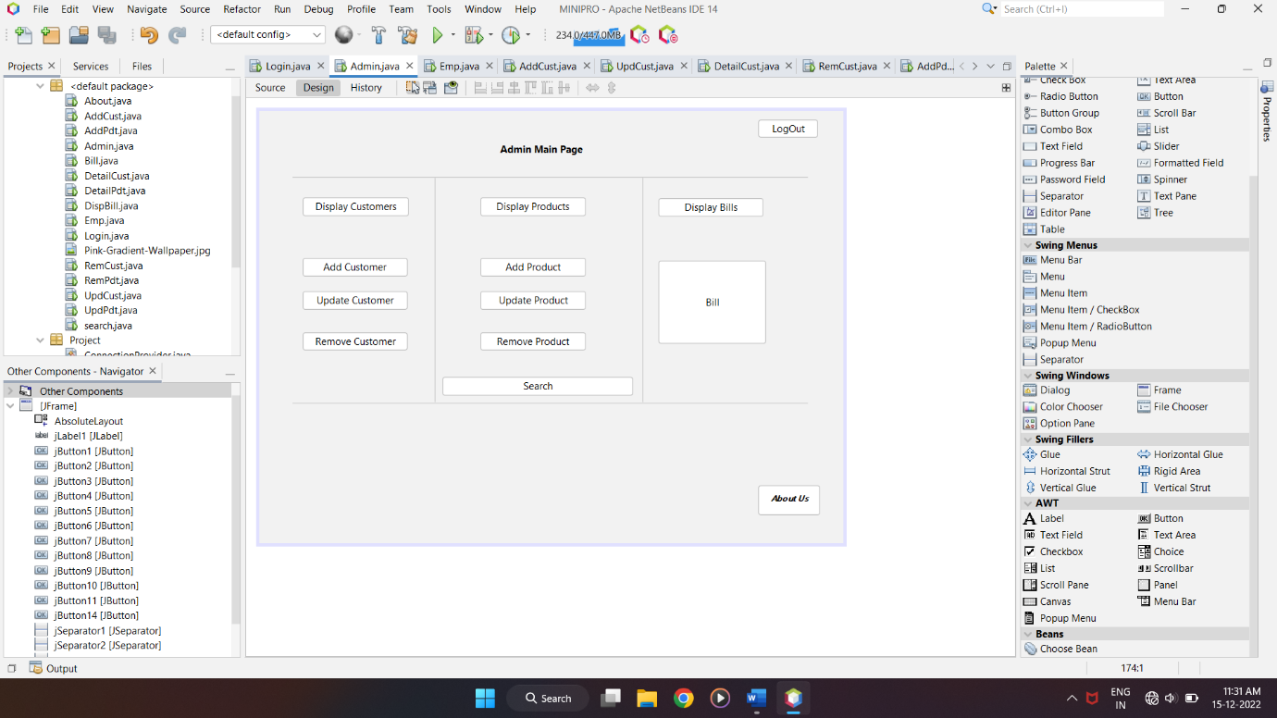

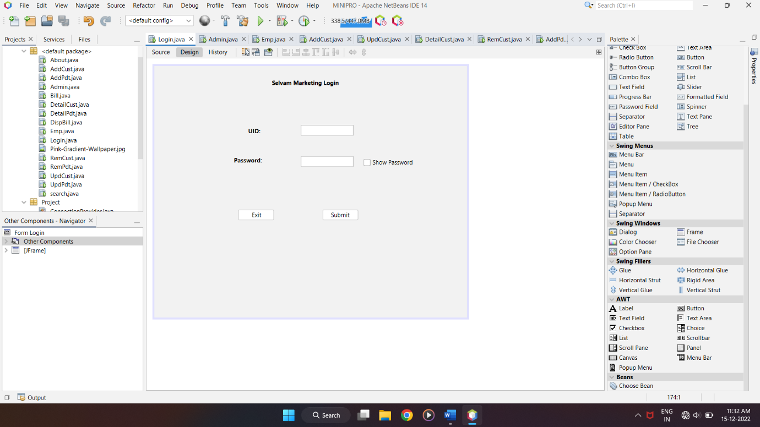

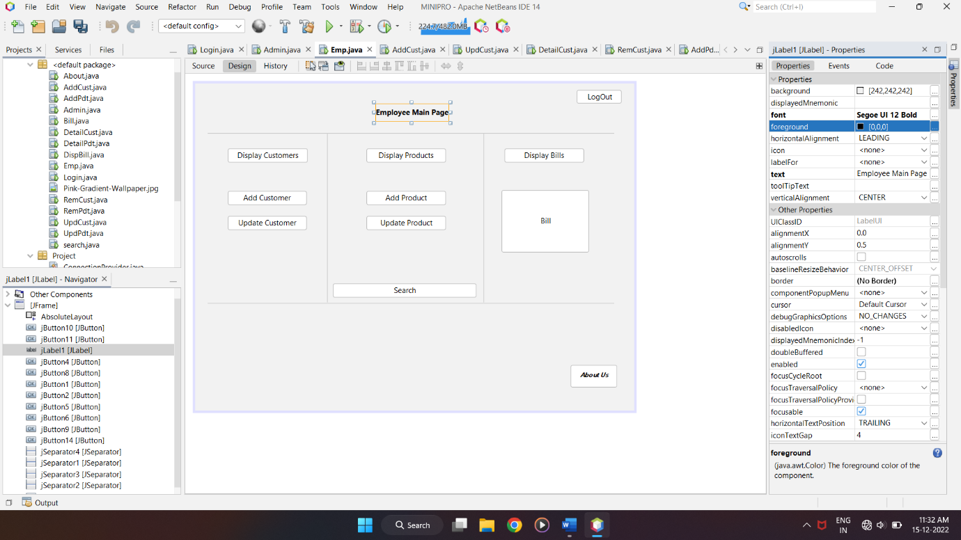

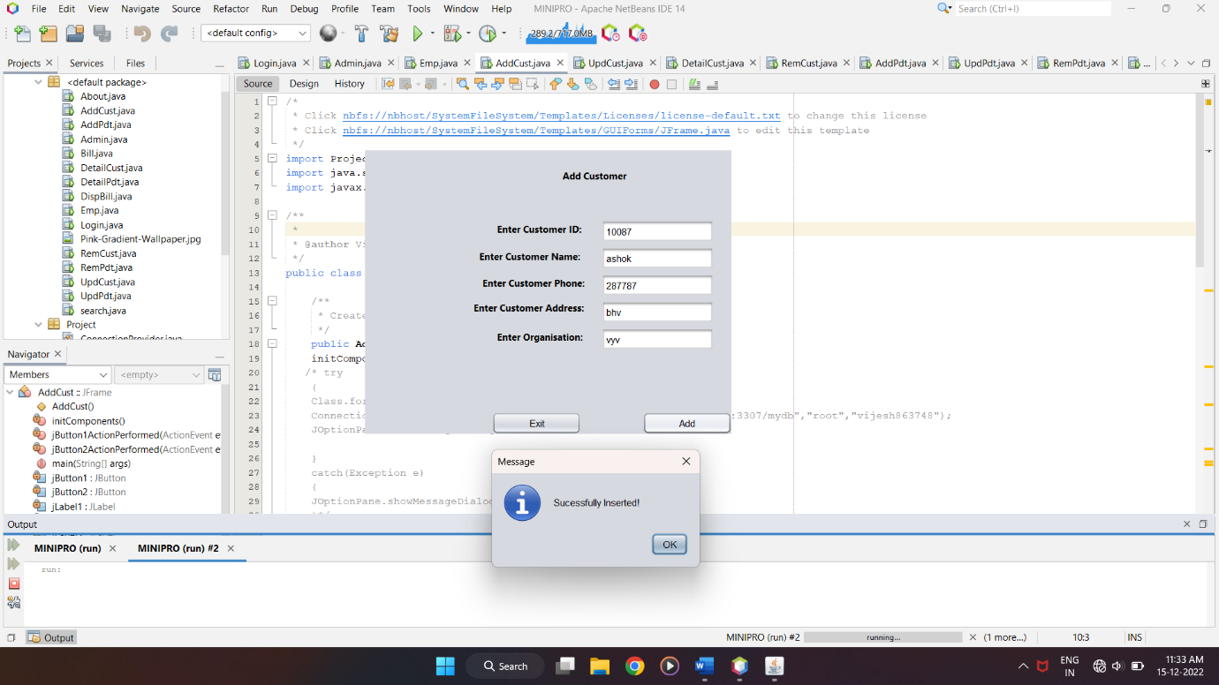

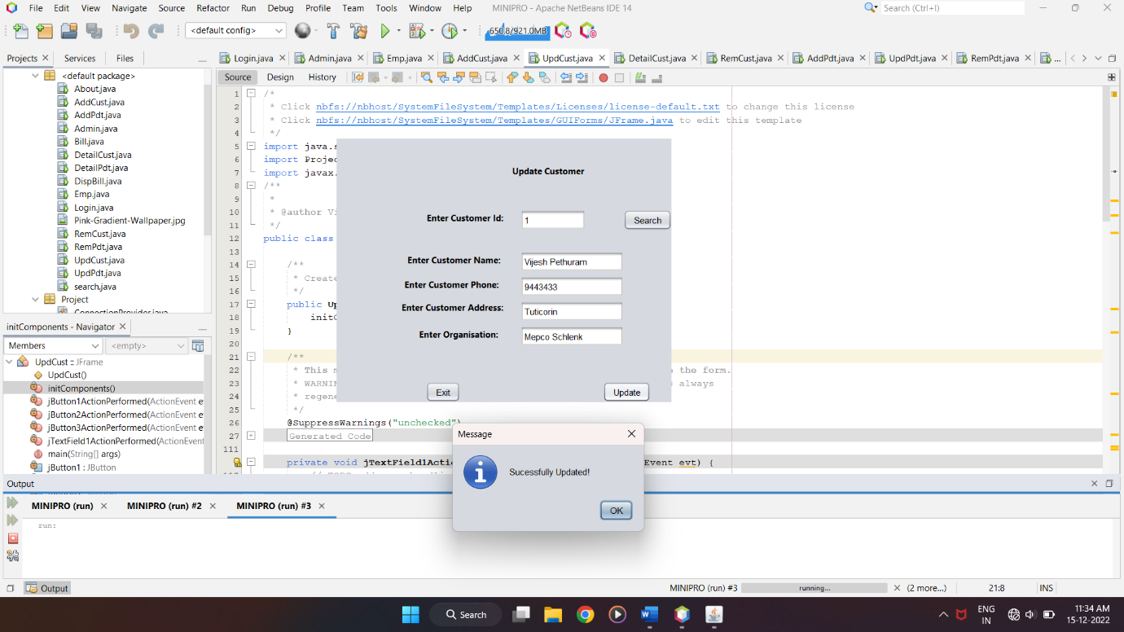

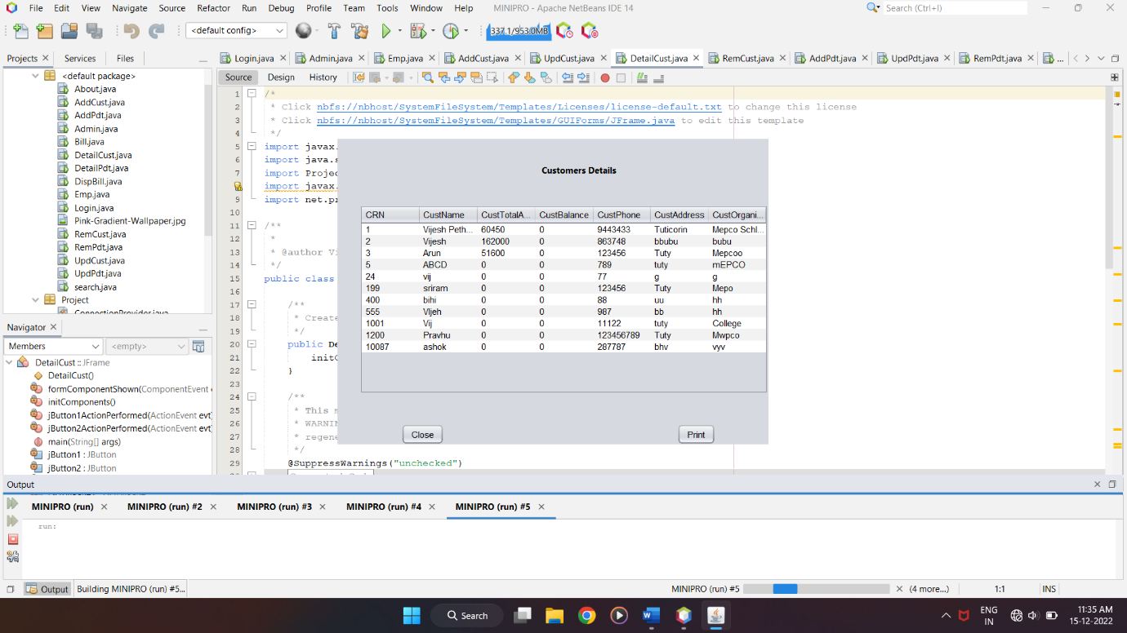

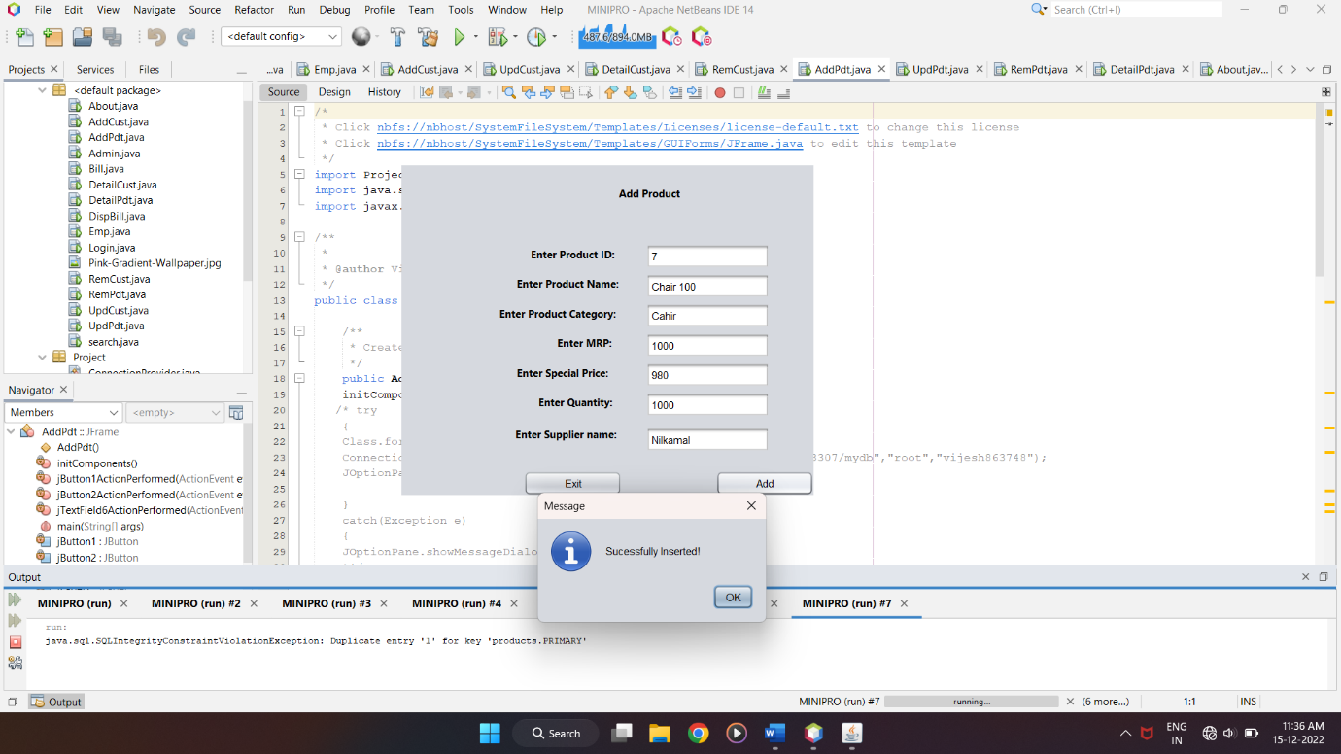

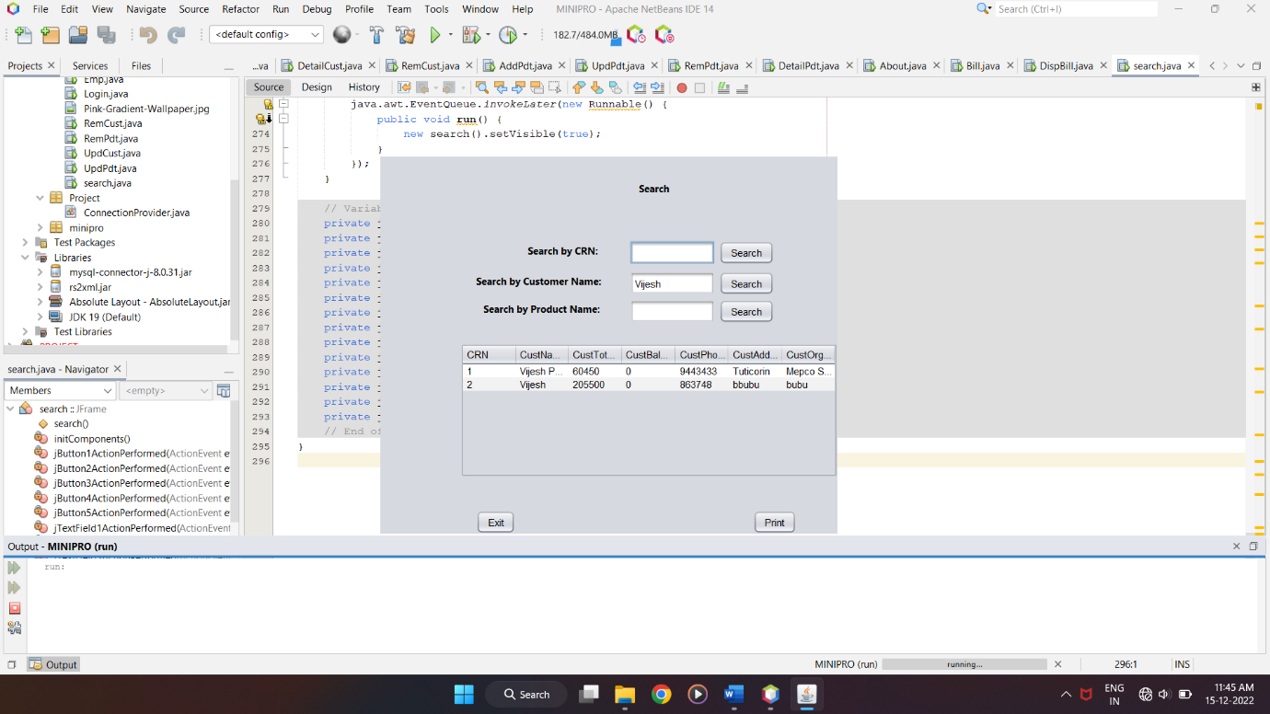

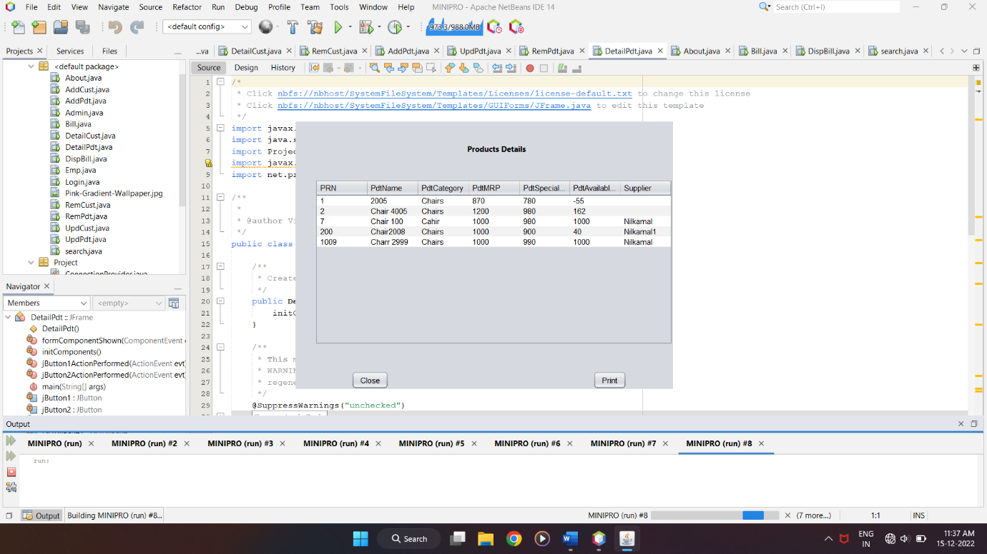

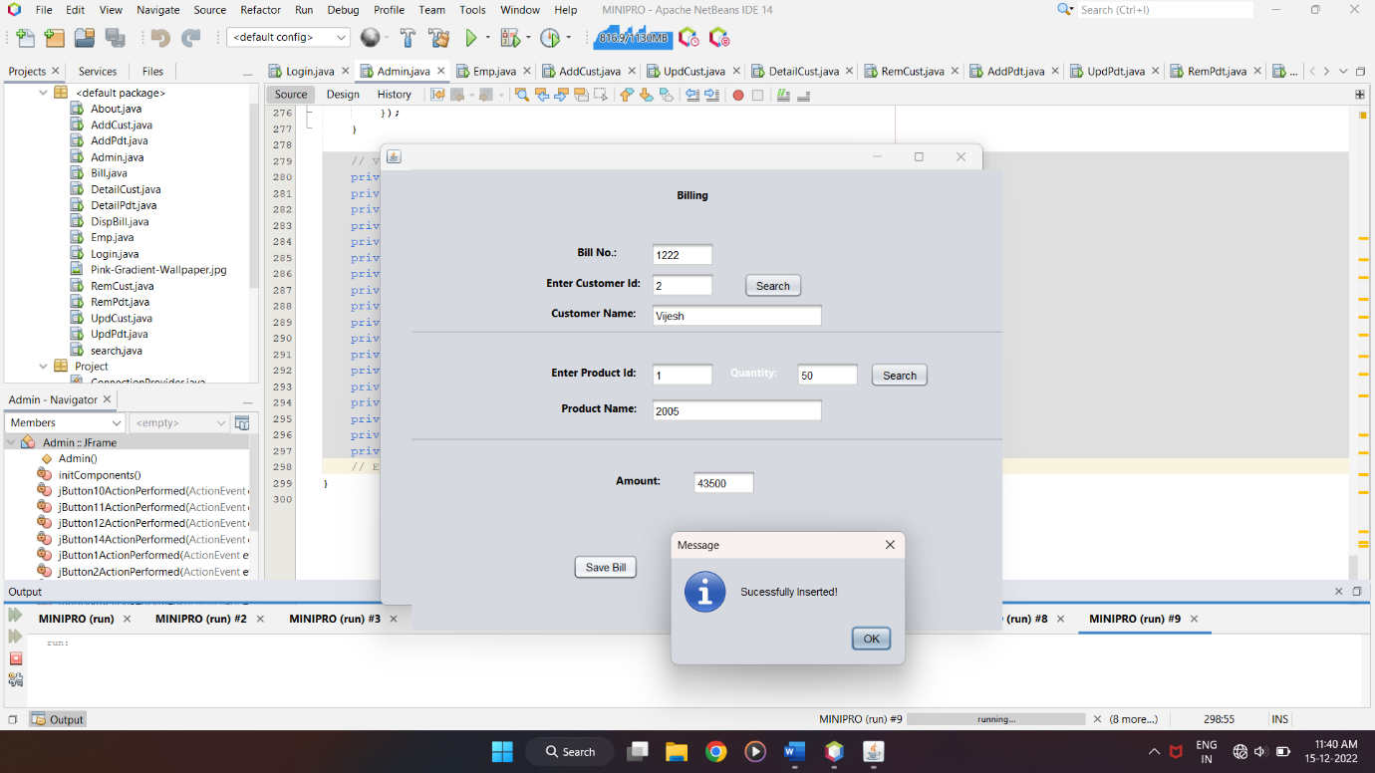

11. Conclusion

Thus, our DBMS project titled ‘Retail Billing Management System’ was done. We hope it would be useful to all businesses.